24 Sample Demonstrations

from the Dutch books “Show the Physics 1&2”

Published by NVOn the Netherlands Association of Science Teachers

Prepared for the IOP book committee

21 September 2018

Table of Contents

[Developing Particle Explanations through Colouring Eggs 2](#_Toc525324259)

[Cappuccino and specific heat versus heat of vaporization 6](#_Toc525324260)

[Making a slanting tower stacking blocks 10](#_Toc525324261)

[No Force Needed to Sustain Constant Speed: Newton’s First Law 12](#_Toc525324262)

[Spectacular Spectrum 17](#_Toc525324263)

[Magic with pendulums 19](#_Toc525324264)

[Magic Memory Balls: Density of Solids and Floating and Sinking 21](#_Toc525324265)

[Air or not, reasoning about flames and vapor 23](#_Toc525324266)

[Does van de Graaff not like a shower? Testing statements about electrostatics with a Van de Graaff generator and soap bubbles 25](#_Toc525324267)

[Falling faster than g, free fall with rotation 28](#_Toc525324268)

[Rotational inertia 30](#_Toc525324269)

[Tug-of-War: can one girl be stronger than four boys? 33](#_Toc525324270)

[Stick-slip motion, kinetic versus static friction 35](#_Toc525324271)

[Self-propelling car violates conservation of momentum? 37](#_Toc525324272)

[Falling magnet and Newtons’ Third Law: does the magnet challenge gravity? 40](#_Toc525324273)

[Who Dares? Stable equilibrium using small bottles 42](#_Toc525324274)

[Dropping balls and bottles, elasticity versus gravity 44](#_Toc525324275)

[Merry-go-around of floating candles, Lorentz force in liquids 46](#_Toc525324276)

[Reflection 48](#_Toc525324277)

[Making Einstein young again with an overhead projector 50](#_Toc525324278)

[Infra-red investigations and surprises 53](#_Toc525324279)

[LEDs and Photons 55](#_Toc525324280)

[Writing with a Laser using Phosphorescence 58](#_Toc525324281)

[Center of mass demo’s, feeling Physics with your own body! 61](#_Toc525324282)

# Developing Particle Explanations through Colouring Eggs

Peter Dekkers

**Time** 30 + 30 + 30 min

**Age group** 12-14

**Concepts** particle model, membranes

## P1100960Introduction

Figure 1 An unboiled egg in vinegar

The activity challenges students to explain what they observe, which is that some substances do, while others do not penetrate the membrane surrounding a raw egg, after its shell is removed. A simple particle model is introduced as a potentially viable explanation. The demonstration presents an example of the way in which models in science arise, and of their value and status. Difficult about particle models is: the particles explain the properties of materials (such as temperature, shape, pressure, colour), *properties that the particles themselves do not possess.* The particles themselves, for example, (are thought to) consist of a point with mass and velocity, whose average kinetic energy ‘explains’ the temperature of the gas. . The demonstration attempts to show that de power of a model is that it helps us to describe, explain and predict (a part of) the real world better than we could otherwise.

## Equipment

10 eggs or more, 10 jam jars (or beakers), 2 litres of organic vinegar (not cleaning vinegar), a heating plate, a sharp (kitchen) knife; syringe without needle. Salt; various food colourings (try an Asian food shop). A choice of other ‘test substances’ from the kitchen: tea, milk, salad oil, instant coffee; coloured soft drinks.

## Preparation

Photograph the 10 eggs. Preserve one egg with its shell, place the rest for about 3-4 days in organic vinegar, to remove the shells. Replace the vinegar halfway if no more bubbles are formed while some of the shell remains. Wash off the last bits of shell under the tap (carefully!). Place each shell-less egg in its own jar.

## P1100965Procedure

Figure 2 Unboiled egg without its shell

### 1. Oriëntation (30 min)

This first step takes about 15 min. (session 1, + 10 min)  
Place the egg that still has its shell in a jam jar and submerge it in vinegar. Let the students observe and describe what is happening. If you like, present the reaction equation when they have done so. Then show the remaining 9 eggs.   
Notably, the eggs have lost their shells leaving them almost transparent. Furthermore, the egg has become larger when its shell was removed. (Compare the egg that has just been placed in vinegar with the rest, and show the photo of the original 10 eggs.) How is that possible?

Students often come up with the following ideas.

*Explanation 1. The egg shell kept the egg together, it has ‘sagged’ while losing its shell.*

Test: if this is correct, it should be possible to compress the material in the egg. Is that the case?  
Cut one of the eggs, fill the syringe with it, remove the air, close the syringe and try to compress it. Conclusion?

*Explanation 2. ‘Water’ has entered the egg.*

Test: place one of the eggs in a pan of water, let it slowly come to the boil and cook it until reasonably firm (about 15 min should do). Open it and taste the contents (so use organic vinegar, NOT cleaning vinegar). Does this observation support the explanation?

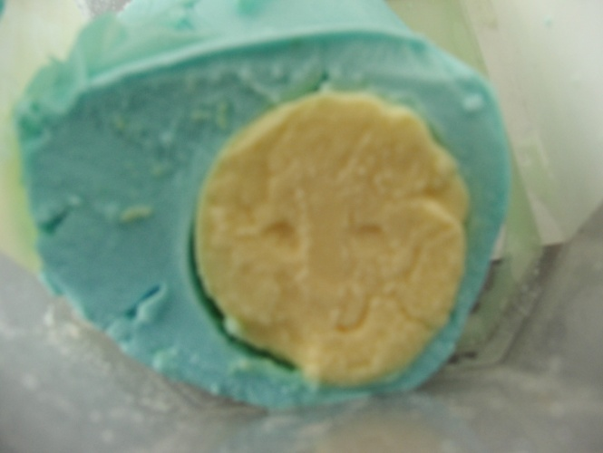Conclusion: vinegar goes through the outer ‘skin’ or membrane of an egg, but egg white does not. How do other substances behave?

Figure 3 Food coloring penetrates the outer but not the inner membrane.

*Research plan*

Together, decide which other substances you want to test (include some food colouring liquids) and how you will do that. One way that works is: place a raw egg without shell in (a solution of) the test substance overnight, the next day let it slowly come to the boil and cook it for a long time, then open it and investigate the contents.

### 2. Collecting and presenting observations (30 min)

The second session continues after the plan has been carried out, and the eggs with test substances have been boiled. The observations of the contents by watching and tasting will lead to the following conclusions, among others:  
- the egg contains a second membrane that surrounds the yolk;  
- egg white and yolk do not penetrate the membrane that surround them;  
- salt and vinegar penetrate both membranes;  
- food colouring liquids penetrate the outer, but not the inner membrane.

Produce a systematic overview of the observations, for example in an observations table like Table 1. The research question has been modified into: *Which substances can penetrate the outer membrane, and which of these can also pass through the inner membrane?*

|  |  |  |  |
| --- | --- | --- | --- |
| **Name of substance:** | **Passes through outer membrane (yes/no)** | **Passes through inner membrane (yes/no)** | **Column 4** |
| Egg white | No | No |  |
| Yolk | ? | No |  |
| Salt | Yes | Yes |  |
| Vinegar | Yes | Yes |  |
| Green food colouring | Yes | No |  |
| Red food colouring | Yes | No |  |

Table 1 A summary of observations

### 3. Interpretations and conclusions, answering the research question (30 min)

What causes some substances to pass through both membranes, others to pass through the outer one only, and yet others to pass through neither? Challenge the students to answer this question. Acknowledge and appreciate all of the ideas the students offer, but critically assess with the whole class whether each of the explanations is indeed able to explain all of the observations.

Subsequently suggest, if that has not been done yet: imagine that a certain substance consists of very tiny particles *that are all of the exact same size*. Particles of other substances may be of a different size. Some substances consist of larger particles, others have smaller ones. Also, imagine that the fleeces are not entirely closed but have tiny holes, similar to the pores in your skin. Finally, imagine that in liquids like yolk the particles are all continuously moving criss cross: think of the balls in a ball pit and imagine that they are all swarming in the pit. In solids, on the other hand, the particles are thought to stay roughly in place, like the seeds in a muesli bar, but shaking about to and fro. It is impossible, however, to see the swarming or shaking of the particles, they are much too small for that, but there are nice simulations to visualize the particles: <https://phet.colorado.edu>

Questions for discussion (to be used for example in a think-pair-share activity)  
Answer the questions below by trying to use the ideas presented above.  
1a. Which membrane then has bigger holes, the outer or the inner one?  
1b. Can you show in column 4 of the observations table which substances have large particles, which have medium size, and which have small particles?  
1c. Can you explain the observations with these ideas?   
  
*Modelling in science*

By further discussion of the questions below, the teacher may clarify, e.g., what the nature is of scientific models, how they are used, and that there are always limits to their validity.

We have carried out a kind of investigation into the properties of substances and eggs.   
2a. What did we do that a scientist would definitely do as well?  
2b. What did we do that a scientist would never do?   
2c. What did we not do, that a scientist would definitely do?  
2d. Can we call what we did a scientific investigation?

Can we now be certain that substances consist of particles, and that fleeces have holes?  
3a. Can you come up with a different explanation for the observations?   
3b. Did you see particles or holes in fleeces? In that case can you be sure they exist?  
3c. Do you think scientists can see the particles? Can they be sure that they really exist?

We used a *model* to explain the observations. The model consists of ideas about the composition of substances and materials. We do not know for certain whether our model is entirely correct, but it does help us to figure out what is happening. People often use a *model* to make it easier to do or understand something. Examples: Google Maps, temperature graphs in the weather forecast, map of the school, X-ray photo at the dentist, sheet music, etc.

## Physics background

The shell of an egg is removed by placing it in vinegar for a few days. Bubbles (of carbon dioxide) and water start forming immediately, as calcium ions go into solution, because the calciumcarbonate of the shells slowly disintegrates due to the acid (CaCO3 + 2H+ →Ca2+(aq) + CO2 (gas) + H2O).

Ernst Mach (1838-1916) aspired to found all scientific theory in concrete observations, and to allow only concepts in scientific theory that can be linked or reduced to empirical observations. These, he thought, would provide a secure and solid base for science, and in fact nothing else could. As a consequence he rejected, amongst others, both the concept of force (because mass and acceleration suffice) and particle theories (since the particles are not directly observable). His approach made Mach one of the founders of a philosophy called ‘logical positivism’, adhered to by many scientists even today, although they do accept the existence of particles. Albert Einstein (1879-1955) had great admiration for Mach, regarding some of his ideas as the starting point for Einstein’s general theory of relativity. But when the young Einstein demonstrated how Brownian motion can be understood on the basis of statistical properties of randomly moving, invisible tiny particles, this was a serious attack on Mach’s approach. Mach rejected Einstein's theories, but Mach’s approach did not survive. The famous physics teacher and Nobel Prize winner Richard Feynman (1918-1988) considered the idea that matter is made up of particles as perhaps the most important idea that scientists have ever come up with (Feynman *et al*., 1963, p. 1-2)

## Safety and environment

Use only safe, harmless substances. Boil the shell-less eggs in a fuming cupboard, if possible.

# Cappuccino and specific heat versus heat of vaporization

Frits Hidden, Jorn Boomsma, Anton Schins, Ed van den Berg

**Time:** 10 - 15 minutes, more if student computation work is integrated in the demo.

**Age group:** 14 - 18

**Concepts/skills:** Heat of vaporization (*Lv*) and condensation, specific heat, applying *Q* = *c.m.ΔT* and *Q* = *m.Lv*

## Introduction

A cup of cappuccino is prepared by adding about 50 mL frothing, foaming milk to a cup of espresso. Whole milk is best for foaming and the ideal milk temperature when adding it to the espresso is 65°C. The espresso itself may be warmer than that. During the heating the milk should not burn as that would spoil the taste. The best way is to heat the milk slowly while stirring to froth the milk and create foam. But modern cappuccino machines in restaurants do not have time for slow heating. Could we heat the milk by just adding hot water?

That’s the question we pose to our high school students first. How many mL of 90 oC hot water would be needed to heat 50 mL of milk from refrigerator temperature (say 4 oC) to 65 oC? Assume that the specific heat of milk is the same as that of water. Students answer the question on a worksheet and practise their computation skills. The answer: 122 g. This would mean an unacceptable dilution of the milk, 2.5 mL of water for every mL of milk. What would the answer be if we use boiling hot water of 100 oC? Students calculate again then the answer is 87 g, still an unacceptable dilution. What then? What if we use steam?

|  |  |
| --- | --- |
|  | opstelling.wmf |
| Figure 1 Cappuccino | Figure 2 Set-up |

## Objectives

Students can:

* Tell that a large amount of energy is released when water vapor liquifies and are aware of the large difference between the specific heat of water and the heat of vaporization (4.2 J/goC versus 2256 J/g).
* Explain how the heat of vaporization can be used when making cappuccino.
* Carry out the relevant computations.

## Equipment

* A large erlenmeyer flask
* Measurement cylinder of van 100 mL
* Thermometer
* Cork or rubber stopper with hole
* Rubber tube
* Water
* Burner
* Heat resistant gloves (to handle the hot rubber tube) or tongs
* Access to refrigerator for cold water or milk

## Preparation

Fill the Erlenmeyer with water, preferably boiling water to prevent waiting by students. Connect the rubber tube with the stopper. Fill the measuring cylinder with about 50 ml water from the refrigerator (5 ml). This water functions as “milk”. Using real milk is fine too.

## Procedure

The first part of the execution consists of computations.

A cappuccino is made by ...... (here follows the text of the introduction **but without the information that a cappuccino machine uses steam**. ….. but what can you do if there is no time to heat the milk slowly like in a restaurant or coffee shop? A cappuccino machine adds “hot water” to heat the milk. The maximum dilution that is acceptable for the taste is 10%. Such a small dilution does not matter as expresso is strong coffee with little water.

Calculate on your worksheet how much water of 90°C has to be added to 50 ml milk of 5°C to heat it to a temperature of 65°C. Assume that the specific heat of milk equals that of water. The formulas and constants you need are on the worksheet (or on the board). (Answer 120 g).

That (120 ml) is more than 2x as much as the milk (50 ml). Suppose we use water of 100 °C, how much do we need then? (Answer 86 g).

That is still more than 1.5 times more water than milk!

Suppose that water would not evaporate at 100 oC. How high should be the temperature of 5 g water to be added to 50 g milk of 5 oC such that the final temperature of water and milk would become 65 oC? Just use the same formulas. (Answer: 665 °C).

That is very high, 665 oC, that is not going to work. Let’s now look at what happens if we use steam, which is what we get when we heat water above 100 oC.

The teacher explains the set-up and asks a student to come to the front to measure the volume of “milk” and its temperature (should be about 5 oC).

Start the experiment. Light the burner. First get the pre-heated water in the Erlenmeyer to boil. Wait until steam comes out of the rubber tube. Then put the end of the rubber tube into the “milk”. The student measurer reads the temperature every 10 seconds. Another student does general observations and is asked to look for bubbles. At about 62 oC the burner is removed. At about 65 oC the tube is removed using insulation gloves or a biceps. Do not wait too long removing the tube because after turning off the burner the remaining steam will condense and reverse the flow in the tube (suction). The observer student measures the final temperature (about 65°C) and estimates how much water was added to the “milk” (about 7 g).

The milk is now 65°C and we only needed about 7 g of steam! Not 86 g! And we did not heat up to 665 oC either. How is that possible, where did the energy come from?

## Physics background

The experiment clearly shows that much less steam of 100 oC is needed than water of 100 oC. When steam condenses to water an enormous amount of energy is released: 2256 Joules per gram steam. This energy is used to heat up the milk. This is comparable to the heat released bij cooling 665 oC water to 65oC if the water would still be liquid rather than steam. A cappuccino machine uses this heat of vaporization to heat up the milk, a clever trick. That lots of energy is released is also clear from the noise. Furthermore, the machine simultaneously froths the milk. Have a nice cappuccino!

## Tips

See the comment on withdrawing the tube timely from the milk before suction appears.

A worksheet is available on the site.

It is possible to do this experiment as student practical work, but watch out with the steam.

## References

Hidden, F., Boomsma, J., Schins, A., Berg, E. van den (2012). Cappuccino and specific heat versus heat of vaporization. *The Physics Teacher*, 50(2), 103-104.

Cappuccino preparation is illustrated in quite a few short YouTube films which you may like to show after the demo.

**Including thermometer:** [**http://www.youtube.com/watch?v=RsBYOY-32S0&feature=related**](http://www.youtube.com/watch?v=RsBYOY-32S0&feature=related)

[**http://www.youtube.com/watch?v=i-LmmjdoAms**](http://www.youtube.com/watch?v=i-LmmjdoAms)

[**http://www.youtube.com/watch?v=u4pBo4hOEhk&feature=related**](http://www.youtube.com/watch?v=u4pBo4hOEhk&feature=related)

[**http://www.youtube.com/watch?v=05mH6q1kdIU&feature=related**](http://www.youtube.com/watch?v=05mH6q1kdIU&feature=related)

[**http://www.youtube.com/watch?v=snZTnkgykcs&feature=related**](http://www.youtube.com/watch?v=snZTnkgykcs&feature=related)

## Safety and environment

Steam can cause bad burns. So watch out with the steam coming through the rubber tube, use insulating gloves or use tongs.

Computation worksheet which could be with supplementary materials on a website

Worksheet Cappuccino

The following formulas can help in solving the problems posed on this worksheet.

General formulas: *Q* = *m ∙ cw ∙ ∆T* en *Q* = *Lv.m*

In this experiment: Qabsorbed by milk= Qreleased by water

50 g ∙ 4.2 J/g°C ∙ (65°C – 5°C) = mhot ∙ 4.2 J/g°C ∙ (Thot – 65°C)

ρwater ≈ 1.0 g/ml ; cmilk ≈ cwater = 4.18.103 J/g°C ; Lv = 2.26 . 106 J/kg (heat of vaporization)

**Attempt 1: water of 90 °C (Thot is 90 °C)**

1. Calculate how many grams of water of 90°C we have to add to 50 g “milk” (could also be water in the experiment) of 5°C to achieve a final temperature of the “milk” to 65°C.

Answer:

**Attempt 2: water of 100 °C (Thot is 100 °C)**

1. Calculate how many grams of water of 100°C we have to add to 50 g “milk” 5°C to achieve a final temperature of the “milk” of 65°C.

Answer:

**Attempt 3: very hot water if it would not turn to steam**

1. Calculate Thot if we use 5 g of very hot water (not steam) to heat 50 g “milk” of 5°C to increase the temperature of the “milk” to 65°C (mhot is 5 g)

Answer:

**Attempt 4: steam of 100 °C**

1. Calculate how many grams of steam of 100°C is needed to heat 50 g “milk” of 5°C to 65°C.

Answer:

# Making a slanting tower stacking blocks

Maarten van Woerkom

**Time**: 20 minutes

**Age group**: 12 and up

**Concepts**: center of mass, stable equilibrium

**Introduction**

If you put two blocks on top of each other, then the upper one remains stable if the center of mass is still above the lower block. So the upper block cannot stick out more than ½ x the length of the block. Is it possible to pile up blocks such that the upper one sticks out farther?

|  |  |
| --- | --- |
|  |  |
| Figure 1 How to can you arrange blocks into a tower that slants as much as possible and yet does not tip over? | Figure 2 Stacking blocks |

## Equipment

A number of equal blocks.

## Procedure

Pile some blocks on top of each other with the instruction: how can you make the end of the top block stick out as much as possible? In other words, how can you achieve the maximum distance between the front of the top block and the front of the bottom block? You can use as many blocks as you want.

Is it possible that the backside of the top block passes the front side of the bottom block?

Usually blocks are stacked one by one. See the 4 blocks in figure 2. First the green block 1, then the orange block 2 that sticks out 1/3 of the block length, then another orange block 3 that also sticks out 1/3 of the block length.

The center of mass of the orange blocks together is now exactly above the front of the green bottom block. So if you would place another block sticking out, the red one, the pile would tip over.

It is also possible to arrange the pile in reverse order from top to bottom (figure 3). Put block one on top of block 2 (counting from above), then blocks 1 and 2 on top of block 3, etc.

|  |  |
| --- | --- |
|  |  |
| Figure 3 Stacking starting from the top | Figure 4 Cross section of the Rotterdam market hall |

## Physics background

When you use the reverse piling method, starting from the top, then very quickly you reach a point where the overhang is greater than the block length.

* Center of mass of block 1 is above the front of block 2;
* Center of mass of block 1 and block 2 together is above the front of block 3;
* Center of mass of blocks 1 – 3 is above the front of block 4.

All of that above block 5 and the overhang is already more than one block length.

## Tips

* Instead of blocks of wood you can also use CD cases or big Lego blocks.
* If you google with the term “markthal Rotterdam”, then you will see on the photographs that the 228 apartments were stacked in a way you will now understand. Teacher Eline Bijker actually started her demonstration of stacking blocks with a photograph of the market hall in Rotterdam (figure 4) and asked her students which construction principle was used. The Rotterdam “markthal” is an indoor market with apartments stacked into an arch shape overhead. It was opened in 2014.

# No Force Needed to Sustain Constant Speed: Newton’s First Law

Peter Dekkers

**Time:** 15-45 minutes

**Age group**: 15-16

**Concepts**: force, speed, acceleration, Newton’s First Law

## Introduction

In this demonstration of Newton’s First Law you can direct students’ thoughts and observations to details that are easily overlooked in a student practical. By challenging students to express their expectations/predictions, compare these and then test them in observations, you can direct the way the students adjust and shape their concepts and beliefs. Different from most demonstrations of Newton’s First Law, no attempt is made to reduce friction to zero. It is merely made negligible.

EquipmentA smooth, flat table that is as long as possible. A retort stand that is as high as possible, with clamps and two pulleys; a hanger with slotted masses; a thin cord that is twice as long as the table; two spring-balances. A cart. Power source and electromotor; two more retort stands each with a clamp and a pulley.

Figure 1 Diagram of the experimental set-up

mass

cart

table

Fhand

Revolving cord

knot

Figure 2 The cart moves along with the knot. Compare the forces.

## Preparation

Build the set-up, see figure 1. Pull the cart toward the right by hand. A mass, attached to the cart by a cord running along pulleys, creates an opposing force. The table is as long as possible, the top pulley is positioned as high as possible, so as to create a long runway. An electric motor (not shown) propels the revolving cord. Select slotted masses so that friction is negligible up to speeds of about 1 m/s, and choose matching spring-balances.

*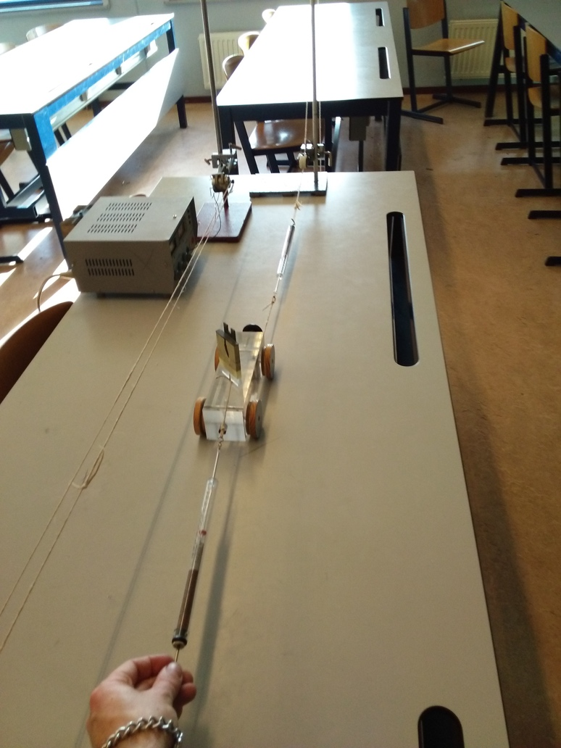*

Figure 2. The set-up.

Procedure  
The cord is revolving uniformly, so a knot in the cord moves along at constant speed. So if you pull along the cart, with a hand that moves along with the knot, that cart has the same constant speed as the knot. The hand and cart take a moment to attain that speed, but then the spring-balances can be read.

*How does the pulling force compare to the opposing force, during that part of the movement? What changes if we select a greater constant speed?* Answering these questions is the aim of the demonstration.

A Predict-Observe-Explain approach is appropriate here. An example is presented in the worksheet below. Students predict in advance, in writing, what they expect will be measured in answering the two questions. Then the experiment is carried out. A (slightly) larger speed is realised by increasing the potential difference driving the electric motor. A conclusion is formulated on the basis of the observations. It is applied in similar contexts to explore whether it is generally applicable.

## Physics background

If an object moves along at constant velocity, with both a propelling force and a force counteracting the propulsion acting on it, then these forces are equal, irrespective of the speed of the object. Furthermore, maintaining a larger speed does *not* require a larger propelling force, if friction is negligible. To maintain the speed, it is enough for propelling force and counteracting force to be equal in size. The ultimate example is a space ship, where the rocket engine can be switched off once the target speed has been reached. *It is sometimes claimed that Newton’s First Law can be verified only in these idealised, frictionless circumstances. But here we see that also in ordinary situations, the net force is zero if the velocity is constant.*

Tips  
Teachers sometimes tend to omit the revolving cord, but then how do you know or verify that the speed is constant?   
The electric motor might be attached directly to the cart, to pull it along. However, especially if you involve students in carrying out the measurements, there is added value in students feeling in their hands that maintaining a higher speed does not require a greater pull.   
Both pulling forces must be made to act at the same height on the cart, or torque may affect and disturb the measurements. If during testing the forward force turns out to be greater than the opposing force, check if the cord did not fall off a pulley. If not, increase the hanging mass. Using about 0,3 kg is normally enough to make friction negligible.   
It is not so easy to maintain a constant speed, (let your assistants) practice a few times before measuring.

In a prototype version of the demonstration, studying the at-rest situation was included. This turned out to be (1) distracting, because friction can no longer be neglected, and (2) unnecessary, because students are well aware that the forces should be equal in that case.

## Opportunities for further inquiry

Students often start raising objections after a short while: “Yes but, surely the forces are not equal at the beginning, when the cart starts to move?” Be alert to note and respond to these remarks, because this is precisely where students’ views *do* accord with Newton’s. From a science educational perspective, our aim is that students come to distinguish conceptually between situations where the cart is accelerating, and those where the speed is constant. Rather than exposing ‘misconceptions’, pay a great deal of attention to this conceptual differentiation, once students express it. Encourage the idea that physics *does* accord with what they already know about motion and its causes but express that knowledge more precisely and accurately.

Obviously, a single experiment will not cause students to expand and differentiate their understandings of force and motion to become fully Newtonian. Many students will still speak of the ‘force of motion’ when they explain why a skater or cyclist keep on moving beyond the finish line, after they stop propelling themselves. In developing Newtonian descriptions and explanations, students need to know when and why something is called a force in physics, and develop the concept of ‘interaction’ (Dekkers & Thijs, 1998), and distinguish force from momentum.

## Literature

Dekkers, P., Thijs, G. (1998). Making productive use of students' initial conceptions in developing the concept of force. *Science Education*, 82, 31-51.

**[Worksheet for website with support materials for the book]**

Worksheet: Newton’s First Law

**A. Set-up and execution**

Figure 1 The cart moves along with the know. Compare the forces.

mass

cart

table

Fhand

Revolving cord

knot

The cart will be pulled along to the right by hand at constant speed. At the same time, the hanging mass is exerting an opposing force on the cart. Friction is negligible.

In that case, how big is the pulling force compared to the opposing force on the cart?

And is a greater pulling force needed to maintain a greater constant speed?

Aim of the experiment is to answer these two questions.

The revolving cord is propelled by an electric motor and moves at constant speed. By moving the hand along with the moving knot, the hand and the cart will also have that constant speed. The cart needs to catch up at the start, but then the spring-balances can be read.

**1. Predict** Use symbols such as: =, <, >, <<, >>

Fill in table 1 (Table 2 remains empty for now). Table 1. Table 2.

|  |  |  |  |  |  |
| --- | --- | --- | --- | --- | --- |
|  | *The speed of the cart is constant and:* |  | *Comparison:*  ***PREDICTED*** |  | *Comparison:*  ***MEASURED*** |
| *a.* | *Low* |  | *Fforward ... Fbackward* |  | *Fforward ... Fbackward* |
| *b.* | *Medium* |  | *Fforward ... Fbackward* |  | *Fforward ... Fbackward* |
| *c.* | *High* |  | *Fforward ... Fbackward* |  | *Fforward ... Fbackward* |

d. Compare the forward force at high speed with the forward force at low speed.

Fill in the prediction, but not yet the measurement:

Prediction: Fforward at high speed . . . Fforward at low speed

Measurement: Fforward at high speed . . . Fforward at low speed

e. Compare the backward force at high speed with the backward foce at low speed and fill in your prediction (not yet the measurement):

Prediction: Fbackward at high speed . . . Fbackward at low speed

Measurement: Fbackward at high speed . . . Fbackward at low speed

**2. Presenting measurements and results**

The demonstrator carries out the experiment, the assistants (two at least) read the spring balances.

Fill in the values in table 2. Also fill in ‘measurement’ in parts d. and e.

3**.** **Conclusion of the experiment**

We investigated only the situation of a cart on a table, but suppose that the results are valid for *every* object that moves with a constant speed. Using table 2, you can then formulate a conclusion that matches the aim of the experiment (on the previous page).

Conclusion:

|  |
| --- |
| If an object moves at constant speed, the forward and backward force acting on it are  . . . . . . . . . . . . . . . . . . . . . . . . . . . . . . . . . . . . . . . . . . . . . . . . . . |

**4. Interpreting the conclusion**

a. Based on your measurements:

i. Is the forward force clearly different at different speeds? YES / NO

ii. Is de backward force clearly different at different speeds? YES / NO

**b.**

i. How can you increase the backward force?

ii. Suppose you do so. What forward force is needed then, to maintain a constant speed?

**c.** If you measured carefully, you have found a rule physicists call *Newton’s First Law.*

Find this law in your textbook. Do your answers to 4a. and 4.b accord with Newton’s First Law? Explain.

# Spectacular Spectrum

Ed van den Berg and Frank Schweickert

**Time**: 15 minutes

**Age group**: 14-18 and special events (parents etc.)

**Concepts**: refraction, dispersion, spectrum, rainbow, prism, lens

The lights go off and then there is this beautiful spectrum on the wall (figures 1 & 2). The demonstration can be used for events to illustrate the beauty of physics, but it constitutes also a useful exercise in lower and upper secondary geometrical optics.

## Equipment

An old fashioned overhead projector (OHP) of which the upper convex lens is removed as only the flat Fresnel plate is used; a transparent plastic container (for example a terrarium from an animal store); water; several A4 sheets of paper; a white wall or projection screen; a piece of white carton.

|  |  |
| --- | --- |
|  |  |
| Figure 1 A container of water on top of an OHP | Figure 2 Turn the OHP a bit, make two slits and there are two spectra. |
|  |  |
| Figure 3 The set-up without slits yet, but also here one will see spectra on the left and the right. | Figure 4 The light rays A, B, and C coming from the Fresnel lens and being refracted twice. See explanation in the text. Simulation by Frank Schweickert. |

## Preparation

Cover the OHP with white sheets of paper. Put the container with water (about ¾ filled) on top of this and arrange the papers such that there is a narrow slit (up to 1 cm) next to the container where the light can pass through (figure 3). Set-up and try out.

## Procedure

1. When the students come in, the spectrum is already visible on the wall.
2. The teacher asks rather trivial questions such as: *what do you see? What does it look like? What do you usually use to obtain a spectrum? Is the image on the wall virtual or real?*
3. The teacher takes the container with water from the OHP and uses the white carton to illustrate that the Fresnel plate produces a cone of light. Tilt the carton a little from the horizontal position and move is upwards. Light rays near the center are very steep, light rays are less and less steep as one moves away from the center.
4. Task for the students: try to explain the following:
   1. *In this set-up what causes the separation of colors (dispersion) and the formation of a spectrum?*
   2. *Why is the spectrum shaped like a rainbow?*

Alternatively prepare a worksheet with light rays A, B, and C (figure 4) drawn from the Fresnel lens up to the container and ask students to sketch what happens to these light rays when entering and exiting the container and use that to explain the image on the wall.

1. A hint from the teacher (if necessary): by covering part of the slit show that the left part of the slit forms the right part of the spectrum image and the right part of the slit forms the left part of the image.
2. See the explanation. We also made a Java simulation which can be downloaded from xxx (Note: the Java simulation still needs to be updated)

## Physics Background

The glass plate of the OHP is a Fresnel lens which produces a cone of light with light rays that are steep near the center of the lens and less steep on the outside. The light rays which form the spectrum come from a small slit next to the container with water and form part of this cone of light. The vertical boundary of water/container and the horizontal water surface together form a prism which produces the separation of colors. Comparison of light rays A, B, and C in figure 4 shows that B is steeper (nearer to the center of the lens) and A and B are less steep. So the image of B (B’ in figure 4) will appear higher on the wall than the images A’ and C’ of rays A and C. Furthermore, light rays A and C cross which can be easily confirmed by covering part AB of the slit (right part of spectrum disappears) or part BC (left part of spectrum disappears.

The spectrum on the wall looks very much like a rainbow, but it is another phenomenon altogether. The rainbow is a virtual image which cannot be captured on a screen and moves along with the observer. It is formed when light rays from the sun (behind the observer) are refracted in water drops. On the other hand our “rainbow” is a real image which can be captured on a screen. Schlichting (2006), the inventor of this demonstration, did some calculations and computed the curvature of the red and blue parts of this spectrum.

Follow-up: There are possibilities for computation in the artikel *Ein Regenbogen ohne Regen* (in German) which is accessible through internet.

## Literature

Schlichtings article: www.uni-muenster.de/Physik.DP/lit/natur.html

# Magic with pendulums

Maarten van Woerkom

**Time**: 20 minutes

**Age group**: 12 and up

**Concepts**: period, resonance

5 or 6 pendulums are suspended from a rod (figure 1). Turn the rod slightly back-and-forth and some pendulums will start moving. By tuning the frequency of the turning, the teacher can choose which pendulum will move.

|  |  |
| --- | --- |
|  |  |
| Figure 1 The broomstick with the wooden balls. | Figure 2 Only the red ball moves, it resonates with the almost invisible subtle turns of the broomstick. |

## Equipment

Use as rod a 70 cm piece of broomstick. The strings should have a thickness of several mm. Use wooden balls with a diameter of approximately 7 cm (available from toy or hobby websites). Give each ball a different color. Drill a narrow hole through each ball and through the broom stick. The string can be secured on either side with a knot.

## Preparation

Practice several times with the rod and balls until your fingers know the resonant frequencies of each ball.

## Procedure

Hold the rod on the two ends (figure 2) in such a way that the balls will be in front of your face and body so the attention of the students will not be on the hands but on the colored balls. Now play a game about which ball will start moving. For example, ask students to concentrate on the red ball. Then make the red ball move with almost invisible turns of the rod at resonant frequency of the red ball. Same for other colors, ask the audience which ball should move and tell them that you can do this through your will power. But of course you make clever use of the different resonance frequencies.

## Physics background

Each pendulum has its unique resonance frequency dependent on its length. Even turning the rod a few mm is sufficient to achieve a large amplitude of the ball if the resonance frequency is used. By practicing you can find out quickly about the proper frequencies.

## Tips

* For a large audience it is better to use a large set-up with long pendulums then the resonant frequency is not too high.
* Refer to other examples of resonance such as the Tacoma Narrows Bridge which collapsed in 1940.

# Magic Memory Balls: Density of Solids and Floating and Sinking

Bart van Dalen

**Time**: 10 minutes

**Age group**: 11-18

**Concepts**: density, floating, sinking, buoyant force (Archimedes Law)

In this demonstration metal balls change into ping-pong balls. Of course that is impossible, but the initial explanation of the presenter also does not make sense. So how does it work? The observations challenge the students to find explanations. A very simple demo which challenges the audience to think about the concepts density, floating, and sinking.

|  |  |
| --- | --- |
|  |  |
| Figure 1 The balls before the transformation | Figure 2 The balls after the transformation |

### Equipment

Three metal balls; three pingpong balls; corn used for making popcorn; any container.

### Preparation

Fill the container with the corn. Push the pingpong balls to the bottom of the container. They should not be visible. Keep the metal balls separate.

### Procedure

Show the metal balls to the audience, pass them along. Meanwhile tell them that they look like normal metal balls, but that they are made of a special memory metal. Then put the balls on top of the corn and tell that they assume the properties of the corn when you heat them up. Let the audience tell you what happens to the corn when you make popcorn. Seduce the audience to use the terms “greater” and “white”.

Put the metal balls on top of the corn, then put the lid on the container and “heat” the corn by shaking the container. The metal balls will sink while the Ping-Pong balls will rise. Open the container: no more metal balls, but instead Ping-Pong balls (figure 2)!

Of course nobody will believe that the metal really changed into plastic, but what happened then? Discussion will occur spontaneously. The surprise of this demonstration will captivate, but to figure out the secret one has to do some hard physics thinking.

Spontaneous reasoning is often going into the right direction, but needs some correction. Chances are that somebody will propose that the metal balls are heavier than the corn. Then let them compare the mass of the three balls with the whole container of corn. Then of course the metal balls are not heavier, but it is not a fair comparison. When you compare more or less equal volumes of corn and metal ball, then the metal ball indeed turns out heavier. That is a good opportunity to discuss density and the meaning of “fair comparison”.

If the metal balls “sink” because their density is greater than that of corn, can you then also explain that pingpong balls will rise when shaking the container? As a check you can put the Ping-Pong balls at the bottom of the container and leave out the metal balls. It was striking that half of the elementary education majors predicted that in this case the Ping-Pong balls would not rise. The characteristics of the buoyant force apparently are quite counter intuitive.

### Physics background

You will only understand the experiment when you become aware that there are two forces acting on the metal ball and the Ping-Pong ball and that you have to compare them before you can predict what will happen. The corn exerts a buoyant force upward which for the metal ball is **smaller** than gravity but for the Ping-Pong ball **greater** than gravity. So the metal balls sink while the Ping-Pong balls will float on the corn.

# Air or not, reasoning about flames and vapor

**Time**: 5-10 minutes

**Age group**: 12 - 14

**Concepts**: phases of water, evaporation, condensation, combustion, air, oxygen

## Introduction

Just above the surface of boiling water, nothing noteworthy seems to be happening or visible. Slightly higher, however, a kind of rising fog is seen. An object placed in that fog gets wet: the fog consists of water droplets. But then what fills the space between the bubbling water and the fog? Is that ‘just hot air’, or not? How could you investigate that?

|  |  |  |
| --- | --- | --- |
|  |  |  |
| Figure 1 The equipment | Figure 2 Inside the kettle well above the boiling water, the flame is smaller. | Figure 3 Inside the kettle right above the boiling water, the flame extinguishes. |

## Equipment

Electric boiler; water; tea light with container (for example a spaghetti spoon); matches (see figure 1); webcam and screen to make a candle visible in the holder for the whole class.

## Preparation

* Put some water in the kettle and let it come to a boil.
* Leave the lid open so that the kettle does not turn itself off.
* Put the candle in the holder and light it.

## Procedure

Discuss the questions in the introduction with the students. Between the bubbling liquid in the kettle and the rising fog above it you see 'nothing'. What is actually there? Experience shows that most students say '(hot) air'. That idea can be tested, because if it is ordinary air, like the air we breathe, there must be oxygen in it. So if we hold a burning candle in the kettle, it would just keep burning if that space contains normal air.

Bring the burning candle down into the kettle, and note that it goes out. Summarize the observations:

* the candle goes out: above the water is a substance that looks like air but it is not;
* bubbles come out of the water;
* water droplets float above the kettle.

Draw a conclusion together. It may well be that the conclusion is *not* that there is water vapor above the liquid. That is not proven. What we can agree on is: 

* what comes out of the bubbles and hangs above the liquid looks like air;
* it is not air, because a candle does not keep burning in it;
* this substance turns into water droplets when it rises higher.

The substance concerned has a name, "steam". Often the fog is said to be made of steam, but that is not scientifically correct. You could conclude the demonstration by together establishing a proper name for the droplets hanging above the kettle. ‘Cloud’, ‘mist’ and ‘fog’ are acceptable names, but your students may think of more imaginative ones.

## Physics background

The air that is above the liquid before it boils is quickly pushed away when the liquid starts to boil. The temperature inside the kettle remains at 100 oC. The water vapor only condenses above the kettle, where the temperature is lower. Due to lack of oxygen, the flame goes out (some knowledge about burning is desired prior knowledge).

## Safety

Working with boiling water has risks. Do not let students come too close; if possible, use a camera and projection to give everyone a good view.

# Does van de Graaff not like a shower? Testing statements about electrostatics with a Van de Graaff generator and soap bubbles

Wouter Spaan

**Time:** 15 minutes

**Age range:** 15-18

**Concepts**: observe and explain; reasoning with charge, electrostatic induction, and the Coulomb force.

## Introduction

The demonstration of the interaction of Van de Graaff generator with soap bubbles is well-known. In the version described below our focus is on the development of explanation and reasoning skills.

|  |  |
| --- | --- |
|  |  |
| Figure 1: The soap bubble gun and the Van de Graaff generator. In this image, most bubbles move away from the generator. Note: better photos will still be made. A good video is available on the website. | Figure 2: The bubbles on the left move towards the Van de Graaff generator, while the bubbles on the right move away from the generator. How is that possible? |

## Equipment

Van de Graaff generator; soap bubble gun; video recording equipment (can be a student phone).

## Preparation

Make sure you can blow the bubbles from above to the Van de Graaff generator for best visibility.

## Procedure

Blow the bubbles from above to the Van de Graaff generator or let a student do this. Ask the students to observe and write down their observations. You will probably get remarks such as *'the bubbles move away from the generator'*. A good observer may have seen that initially the bubbles are moving towards the generator.

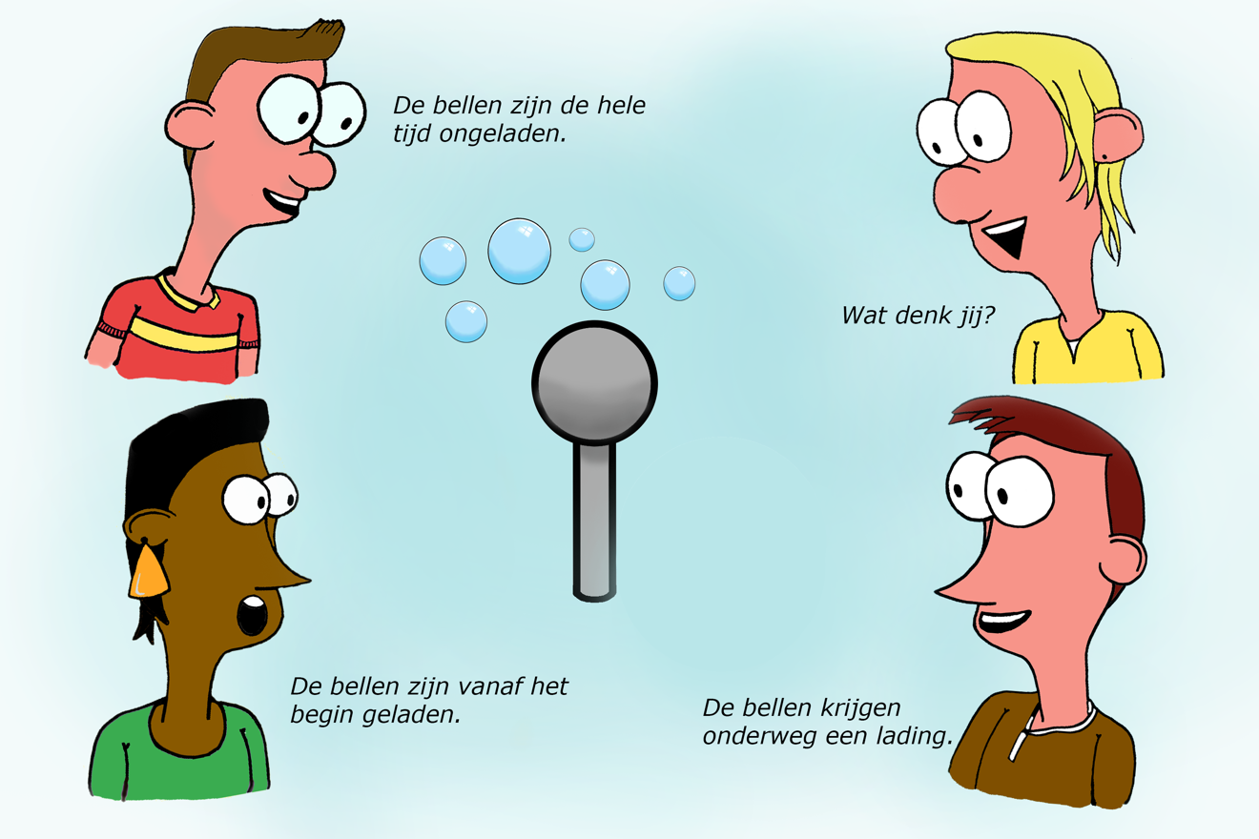

Figure 3 Concept cartoon, the bubbles are neutral throughout, OR the bubbles are charged throughout, OR somewhere along the way the bubbles acquire some charge.

Note: statements to be translated yet . 1) The bubbles carry no charge throughout, 2) the bubbles are charged from the start, 3) the bubbles acquire charge on the way, 4) what do you think?

Then you start the process of developing explanations and testing them with better observations. The concept cartoon (figure 3) can be helpful as a start. It is important to determine the observable consequences of the proposed explanations in a classroom discussion first, so that you can investigate which explanation is the best one:

1. The bubbles are neutral (not charged) throughout the process: the bubbles will move towards the Van de Graaff generator just like small pieces of paper.
2. The bubbles are charged from the start: depending on the charge of the bubbles they will move towards the generator or away from it.
3. The bubbles acquire charge on the way: the bubbles will change their behavior halfway. First they move towards the generator (as in explanation 1) and then their behavior depends on the charge of the bubbles (as in explanation 2).

You can then record the experiments on video and play them on the screen. Blow several series of bubbles so that you will have enough video recordings. First the students can improve their own observations and then discuss which explanation best fits the observations. The film can be played more slowly and then you will see clearly that the bubbles initially move towards the Van de Graaff generator, only to turn around and move away eventually (or burst). Obviously, number 3 (the bubbles acquire charge on the way) is the correct conclusion, although some students will probably persevere in a different opinion. For a complete explanation it is important to focus on the moment the bubbles change their behavior, since there is no explanation to the crucial question how these bubbles get charged, yet. It turns out the bubbles change their behavior just after one of them hits the generator and pops. Sometimes it can also be seen that the bubbles move away from each other, but this is not always visible.

Finally, it is important to look back from the perspective of doing research. From

possible explanations (hypotheses) we have formulated observable consequences (predictions) to investigate through an experiment which explanation is (probably) the correct one. This provides a nice insight into the world of research. Hopefully this also shows that doing research is fun.

## Physics background

Initially, the bubbles are attracted by the Van de Graaff generator through electrostatic induction: the dipolar water molecules align with the electric field of the generator. Because the field is inhomogeneous, there is a force towards the charged sphere of the generator. As a result, initially the bubbles move towards the Van de Graaff generator. They have no net charge yet! When the first bubble touches the generator sphere, it will receive the same type of charge as the generator and it will burst. The drops also have the same charge and are thus repelled by the sphere. Those drops hit the bubbles that are still on their way to the generator, and as a result these bubbles also get the same type of charge as the Van de Graaff generator. This then causes a repulsive force and the bubbles will start moving away from the generator. A new series of bubbles will initially be attracted again and so on.

## Tips

There are even more ways to work on research skills with this demonstration:

* If the students write down their observations, then you can choose to pay attention to the objective formulation of observations. For example, what is the difference between *'the bubbles are attracted by the sphere'* and *'the bubbles move towards the sphere'*?
* You can discuss the difference between a hypothesis and a prediction. A hypothesis is independent of the experiment, the prediction is dependent on the set-up of the experiment. One possible hypothesis is *‘the bubbles are negatively charged from the beginning’*, a potential corresponding prediction is *'the bubbles will move away from the negatively charged Van de Graaff generator’*.

# Falling faster than g, free fall with rotation

**Time**: 5 minutes

**Age group**: 15 and up

**Concepts**: acceleration of gravity g (=9.81 m/s2), free fall, rotation

Everything that falls freely should experience an acceleration g? Or not? Are there exceptions?

**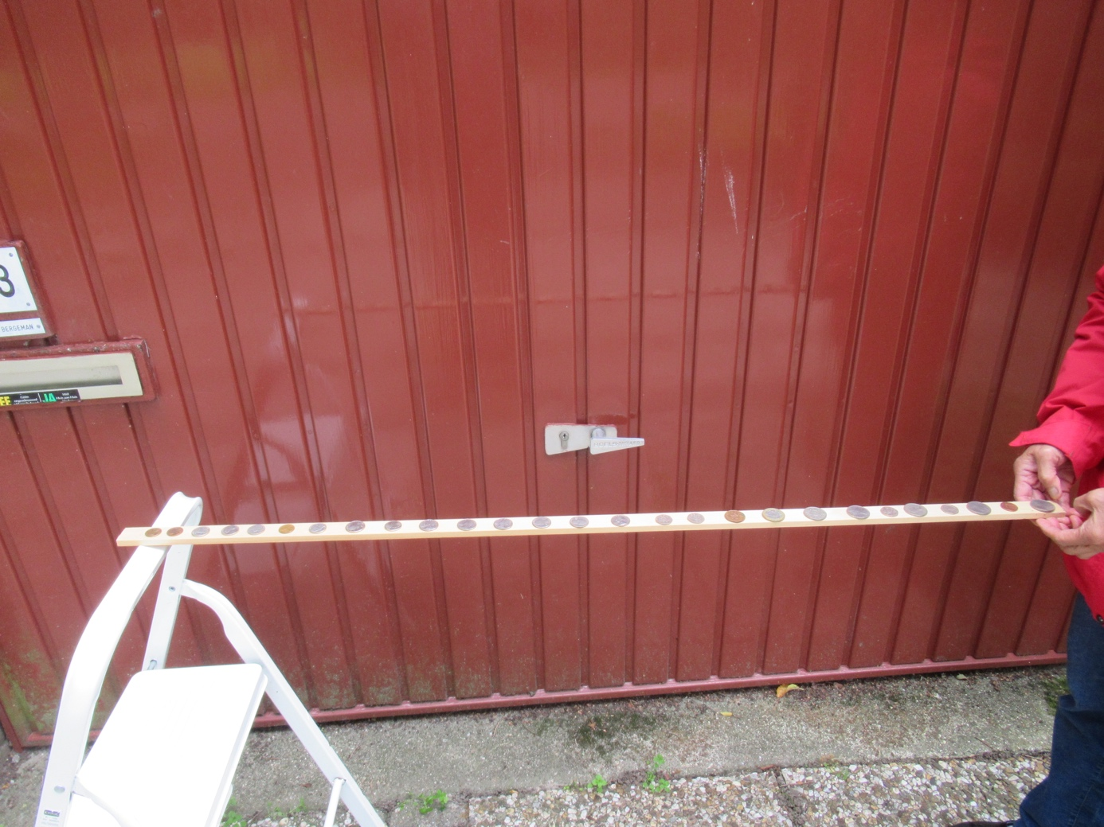**

Figure 1 Set-up of experiment

## Equipment

Meter stick or equivalent. About 30 coins (teacher can borrow from students, they could be pennies or pounds, whatever). If possible a high-speed camera. The iPhone6 can do 120 or 240 frames per second. Cheap action cameras can do 120 frames/second as well.

## Preparation

Think how the visibility of observations can be maximized. For example, put a chair on top of a table and use that as one of the endpoints of the meter stick. Distribute the 20 coins more or less equally across the length of the stick.

## Procedure

1. *Can I accelerate my hand faster than g? How can we investigate that?*  (Coin or stone on the hand, then pull down the hand as quick as you can).
2. *What is free fall? Can objects in free fall be accelerated faster than g?*
3. The teacher holds the meter stick and the 1-meter end while the other side rests on the chair on top of the table (figure 1). *Suppose I let the end of the stick go, what is then the acceleration of the end?* What is the acceleration of other points of the meter stick? (All points of the meter stick have the same angular acceleration, but must have a different linear acceleration as they cover different vertical distances in the same time.)
4. *How can we investigate this with our set-up?*
5. Let’s first keep the meterstick horizontal and drop it. The teacher now holds both ends. *Would the coins keep their contact with the stick?* Execute! If there is a student with an iPhone, then film with 120 or 240 frames/second.
6. Now put the meter stick with one end on the chair on the table while the teacher holds the other end. Mark the 67 cm point but do not yet tell students why. The teacher let’s go, hopefully a student can film this.
7. It would be good to repeat and now ask students to specifically pay attention to the end of the stick.
8. Then follows a discussion about the linear acceleration of different points of the meter stick. This cannot be the same in rotational movement. If there are points which accelerate at less than g, shouldn’t there be points that accelerate at more than g? Did we see that?
9. *From our observations, which points accelerate with g or less? Which points with more than g*? The separation is at 2/3 of the stick, so at 67 cm.
10. Rotation physics is often not in the curriculum. So we will not derive theoretically that the point with acceleration g is at 2/3th of the meter stick. But we do ask our students for examples of similar phenomena. For example, a ladder which is put up too steep and turns over, a factory chimney which is blown up and falls over, a swimmer who stands on the diving board and lets himself fall over without jumping, etc.

## Physics background

The moment of force on a meterstick with length *L* is *mgL/*2. Dividing this by the rotational inertia (1/3*)mL2* we obtain 3*g/*2*L* for the angular acceleration (analog to *ma/m* for linear movement).

The linear acceleration at a point on the stick is the product of (distance from point to the rotation) \* angular acceleration. This will be greater than g for points farther than 2*L /*3.

## Tips for follow-up

Using the coins as indicator one can investigate shorter and longer sticks. You can move the center of mass of the stick by taping on pieces of wood in different positions. You can also conduct video measurement using films from the iPhone or a high-speed camera. Students could do projects and could then study rotational physics first, for example from well known physics texts such as Young & Freedman (2016).

## Notes

This description was inspired by Ehrlich (1990, p. 82).

## Literature

Ehrlig, R. (1990). *Turning the World Inside Out and 174 other simple physics demonstrations*. Princeton: Princeton University Press (p. 82).

Young, H.D., Freedman, R.A. (2016). *University Physics with Modern Physics*. Pearson. (16th edition and all older editions).

# Rotational inertia

Ed van den Berg

**Time:** 10 minutes

**Age group:** 15 and up in physics lessons but also at open days or other 'events' for all ages

**Concepts**:  acceleration, mass, inertia, rotational acceleration, rotational inertia (= moment of inertia), center of gravity, mass distribution

## Introduction

What does the *m* mean in ΣF=ma ? Inertia, or 'resistance to acceleration', this is the essence of the mass concept which usually receives little attention. *Rotational inertia* - "resistance against rotational acceleration" - is usually not included in secondary curricula, but it is very simple and can be spectacularly demonstrated with everyday objects. No time in the secondary curriculum? Ten minutes of inspiration always pay off!

|  |  |
| --- | --- |
|  |  |
| Figure 1 Linear inertia: pull a glass of water at a constant speed across the table, then near the edge suddenly speed up. | Figure 2 Balancing a stick or a rod. |

## Required

A glass of water on a dry sheet of A4 paper; a ballpoint or pencil; a slightly longer stick or rod; a hammer; a meterstick or a rod; a broom; a broomstick or PVC pipe; other items of your choice; a full roll of toilet paper and one that is almost finished.

## Preparation

Prepare the objects needed. A few powerpoint slides might help. Make sure the bottom of the glass of water is dry and so it does not stick to the A4 sheet as a glass of tap water collects condense easily.

## Procedure

Linear inertia, elicit prerequisite knowledge: Put a glass of water on a dry sheet of A4. Pull the paper with the glass of water slowly at a constant speed to the edge of the table, the glass just goes along. Then give a sudden jerk to the paper. The paper is off the table, the glass stays behind on the table. Explanation: at a constant speed the glass goes along nicely. When accelerated the glass (mass) resists acceleration, it stays behind, we call that inertia. The glass of water resists linear acceleration. In formula language we know Σ *F* = *ma*; in it *m* the mass of glass plus water, is the inertia. With a given constant force, heavier objects experience a smaller acceleration than lighter ones. Heavier objects have more “resistance” against acceleration.

Now take a ballpoint pen or pencil, put it upright on your hand and try to balance it on your hand (upright). Let pupils participate with their pencil or pen. It does not work. The pen immediately falls and we are not fast enough to correct the rotational movement. Take a ruler or meterstick. That is much easier. When it starts to fall, we can always correct in time before the stick really falls over. Take a longer stick or broomstick and the balancing becomes much easier. You can easily keep balancing a broomstick for an hour or more! You could almost keep a book in the other hand and read while balancing. Explanation: analog to the translation movement, there is resistance to rotational acceleration. The longer the stick, the slower the stick begins its rotation. We call this resistance to an angular acceleration: *rotational inertia.* The demonstration shows that longer sticks have a greater rotation inertia.

Now take a hammer or a stick with a weight on top. Put the handle on the finger and the iron on top and balance. That is relatively easy. Turn the hammer over and try to balance it with the iron on the finger. That turns out to be a lot more difficult. Again, the longer the stick or handle, the easier it is to balance. And the farther the weight is from the pivot point (from the finger), the slower rotation sets in. The rotational inertia increases with the mass of the object and the distance from the center of gravity to the supporting pivot point.

Story and test: In the circus they do this kind of experiment with a long stick and a girl on top. Suppose we have a stick with the girl, and another, equally long stick with the mother of the girl, for whom is rotation easier to prevent, for the girl or the mother? Why?

1. Application in daily life: in the toilet you can easily tear off a piece of toilet paper from a new roll with one hand with a jerk. With a roll that is almost finished, everything will come off if you try. Put both rolls on a stick and demonstrate!

|  |  |
| --- | --- |
|  |  |
| Figure 3 Who is easier to balance, mother or daughter? | Figure 4 Tearing off a piece of paper with one hand is easier with a full role which has greater rotational inertia. |

Next time: take rolling objects such as empty cans, cans filled with sand, cans filled with water, or even cans of soft drinks, shaken or not. Let them roll from a sloping surface (table) and see what happens. Which has the greatest rotational inertia?

## Physics background

The parallel between linear movements and rotations is interesting. The linear inertia is the mass *m*. The rotational inertia is called the moment of inertia in physics and is indicated by the letter *I.* For an object with a mass *m* that turns around a fixed point at distance *r* is: I=mr2

Then compare the following situations:

*Linear movement*:     Σ*F* = *ma* (1)

The sum of all forces on an object is equal to the product mass *m* \* acceleration *a*.

*Rotational movement*:  Σ*τ* = *Iα* (2)

The sum of all torques that cause an angular acceleration α is equal to the product of rotational inertia *I* \* angular acceleration *α*.

See a university level mechanics text for the restrictions to equations (1) and (2).

## Tips

Increase attention and entertainment, for example by pulling the glass in (1) close to the edge before the paper is pulled away. When balancing a long stick: *see how long I can keep this up, who knows you're still here at 6 pm*.

## Further research

Put the table higher on one end and then let different objects roll off the slanting surface. For example, cola cans shaken or not, empty tin, tin filled with sand, and so on. Which comes first, which last? Relating to rotation support. More mass at the edge; than greater moment of inertia, so slower. With liquids a can can rotate without the liquid rotating, but with first shaking and therefore turbulence in the can that process is disturbed.

## Safety

No safety problems, but do not let the broom hit someone's head when balancing.

## Tested

By the author with large groups in shows and on open days.

# Tug-of-War: can one girl be stronger than four boys?

Freek Pols

**Time**: 5 minutes

**Age group**: 15-18

**Concepts**: forces, components of forces, analyzing forces

## Introduction

Can one girl be stronger than 4 boys? Sure! if she is clever…

## Equipment

4 boys, 1 girl, 1 strong rope

## Preparation

Ask four strong boys and choose one girl as volunteers to help.

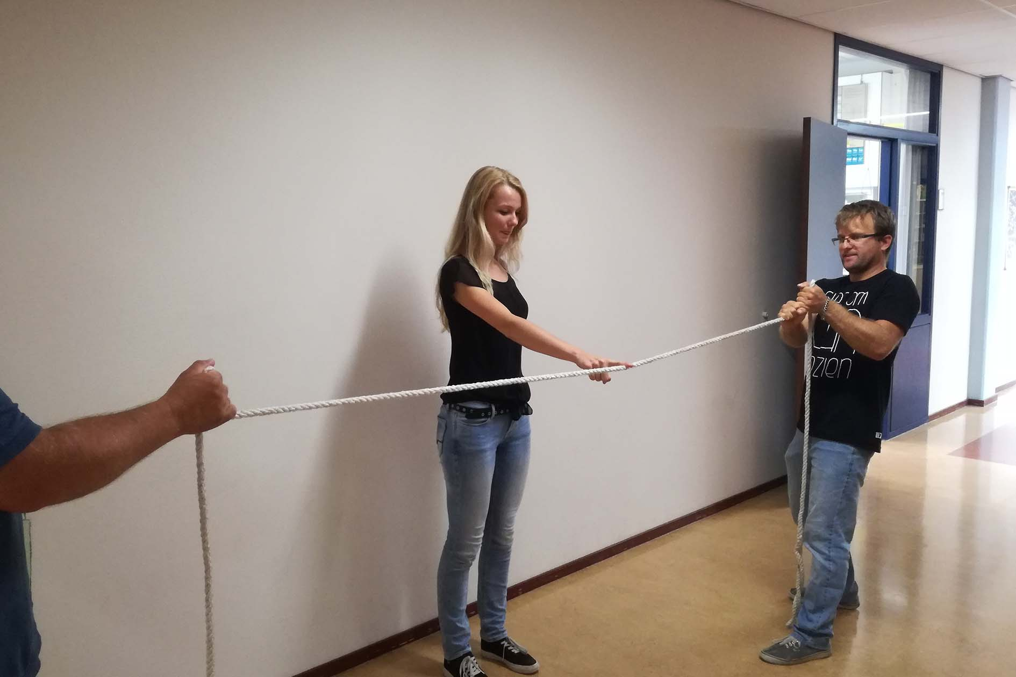

Figure 1 Demonstration set-up

## Procedure

Ask the four boys whether they are, together, stronger than the girl. Let the four boys take up the rope, two on each end and encourage them to pull hard and keep the rope stretched horizontal. Then ask the young lady to use her finger to push the rope downward in the middle (figure 1). The boys will *not* succeed in keeping the rope tight and horizontal.

Ask the students in the class to explain why the boys cannot keep the rope tight and horizontal. Make a simple drawing on the board and demonstrate that a vertical force of 50 N exerted by the girl requires each boy to exert a force of more than 700 N when the angle between the rope and horizontal is 1 degree. This is a surprisingly large force to compensate the small vertical force exerted by the finger.

## Physics background

The boys exert a horizontal force. While the rope is horizontal, this force does not have a vertical component. When the rope is pressed downward by the finger, there will be a vertical component of the force of the boys, however, it is 2·Fboys on rope sinα = -Flady on rope. Angleα is the angle between rope and the horizontal and so very small. So

Fboys on rope = -Flady on rope /2·sinα.

## Tips

Another version of this demonstration was published by Vollebregt and Hooyman (2007). They connected two ropes on either side of a crate of beer and told the boys to pull so hard that the ropes would be horizontal. Impossible!

## Follow-up

Use photographs of cable car and powerline set-ups to calculate the tension in the cables.

## References

Vollebregt, M., Hooyman, C. (2007). De rol van de docent bij probleem-stellend onderwijs, op weg naar een andere lesaanpak. NVOX, January 2007.

# Stick-slip motion, kinetic versus static friction

Ineke Frederik

**Time**: 15 minuteS

**Age group**: 16-18

**Concepts**: kinetic and static friction

## Introduction

Friction is an everyday phenomenon. How would the world behave without friction? We describe some demonstrations which do not cost anything but show very clearly the difference between friction when there is no movement (static friction) and friction when two surfaces move relative to each other (kinetic friction). Many interesting applications can be found when static friction becomes kinetic friction.

|  |  |
| --- | --- |
|  |  |
| Figure 1 Static friction is greater than dynamic friction. | Figure 2 Stick-slip demonstrated with a tray pulled with a weak spring and a string. |

## Equipment

Smooth pvc-tube (diameter32 mm); piece of cloth which easily slips over the surface of the tube (figure 1); small metal tray (figure 2); spring (not stiff); string; washers.

## Preparation

Test whether the cloth slides easily across the tube. Check whether it slides off towards one side as soon as the tube is tilted a bit.

Connect the spring to the small metal basket and attach a string on the other side of the spring. Make the container heavier using some washers or weights.

## Procedure

Hang the piece of cloth across the horizontal pvc-tube . One end should be lower than the other, but the cloth should not slide sideways due to static friction. Then move the tip of the tube gradually downward. The cloth starts to slide, not only downward, but also sideways! As soon as the cloth starts moving a bit, it will also slip sideways and rapidly slide off the tube. When moving, the friction is kinetic friction. Kinetic friction is smaller than the static friction which kept the cloth in its place initially.

Put the tray on the floor then pull the string and walk with constant speed across the room, it is a bit like walking a dog (here the tray). The tray will jump ahead, stand still, jump ahead, etc.

Ask your students for more examples of this phenomenon.

## Physics background

When the piece of cloth is not moving, static friction ensures that the cloth does not move, even though one side is longer than the other. Once it starts moving, friction becomes kinetic rather than static and this kinetic friction turns out to be insufficient to compensate for the difference in weight of both sides of the cloth.

Through static friction the tray remains at rest until the force is big enough to overcome friction and the tray starts moving. While moving, the spring becomes shorter and yet the tray keeps moving, kinetic friction is smaller than static friction. That is until the spring becomes so short that the pulling force is smaller than kinetic friction. Now the tray stops and the process repeats itself.

*Stick-slip* is jerking motion which occurs when a moving object stands still for a moment (sticks) and then jumps forward (slips). The effect may repeat itself continuously. It is the same phenomenon, which occurs when a piece of chalk is moved perpendicular to a traditional blackboard and produces a very unpleasant screeching sound. But also the screeching brakes of a car and the movement of a bow across the violin strings are examples of stick-slip friction, as well as earth quakes when layers of rock move across each other.

A bag drawn across a table with a string might exhibit stick-slip motion as well.

## Literature

YouTube has many stick-slip examples.

Balsma, E. (2008). Wrijving op een koopje. *NVOX, 33(3),* 90-91.

# Self-propelling car violates conservation of momentum?

Leo te Brinke

**Time**: 15 minutes

**Age group**: 15-18

**Concepts**: (conservation of) linear momentum, Newtons third law, rolling resistance

Conservation of linear momentum can be shown by mounting a pendulum on an easy-rolling cart. Pendulum and cart will always move in opposite directions. At the moment the pendulum is released the total linear momentum is zero, and of course it will stay that way.

If the cart turns out to ride away, even if it is in a jerky way, something must be wrong with a fundamental conservation law, isn’t it?

Most of us know from our childhood that if you’re sitting in a cart, you can move forward without touching the ground, just by moving your upper body back and forward in the right way.

This experiment will only succeed if the cart is not running too smoothly, so friction is part of the secret. It’s not really a spectacular experiment, but it’s something that gets you thinking about physics.

*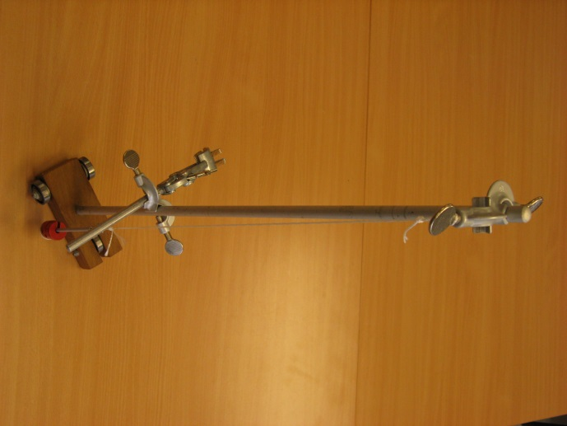 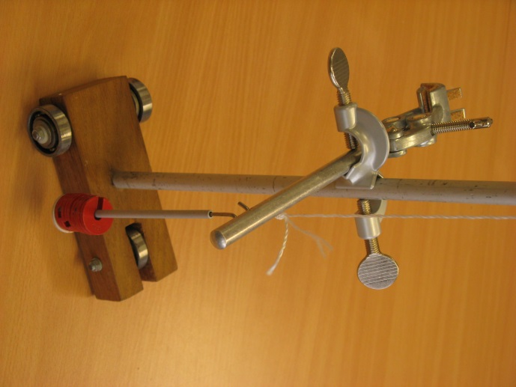*

Figure 1 A self-propelling car Figure 2 Showroom-view

**Equipment**

A suitable cart with a specially-prepared asymmetric pendulum, with a suitable mass on a suitable surface.

## Preparation

The cart should run with a small amount of friction, and it is important that this rolling resistance force with the underlying surface is constant. Our cart isn’t much more than a block of wood with three ball-bearings as wheels.

* Mount a pendulum on the cart, make sure the whole construction, including the pendulum plus weights, is stable.
* Mount about halfway the pendulum a cross bar to stop the string of the pendulum. It must be easily removable and adjustable in height.

So this pendulum is alternatingly long during half a period and short during the other half period.

Now it’s a matter of trial-and error: due to resistance the cart should only move during the ‘short’ half-period, and not during the ‘long’ half-period. To achieve that you can vary and tune the following variables to maximum effect:

* the amplitude
* the mass of the pendulum
* the height of the cross-bar
* the mass of the cart itself
* de underlying surface

After all the cart should jerkily ride into one direction, after releasing the pendulum. A short video can be viewed on https://www.nvon.nl/leswerk/showdefysica2-demo-b18-de-zelfrijdende-auto

Our cart has a total mass of about one kilogram (including the pendulum), the mass of the pendulum is 0,10 kg, the pendulum has a length of 65 cm and the crossbar is about 45 cm underneath the point of suspension.

## Procedure

First show the cart without cross-bar and ask for predictions what will happen after the pendulum has been released. Verify the predictions and discuss the outcome; this can be done considering conservation of momentum or Newtons third law.

Then show that the cart doesn’t move when the amplitude is too small, and discuss the reason for this.

The final question is whether there is a way to get the cart moving in one direction. After having discussed that, it is time for the experiment: mount the cross-bar and show it…

Ask the audience to look closely at the motion of the cart: during which stage of the oscillation does it move?

The discussion that follows must make clear in which way the properties of rolling resistance are responsible for this phenomenon.

After that there might be discussion about the question if this could also work with a sleigh, an air-cushion vehicle, or a boat.

## Physics background

The pendulum bob is alternatingly accelerated and decelerated to the left and to the right. So there must be an alternating force from the suspension point on the pendulum bob and - according to Newtons third law - also from the pendulum bob on the suspension point. It is important to realize that a force on the suspension point also means a force on the cart.

If there is only mutual interaction the total linear momentum will be conserved which causes the momentums of the cart and the pendulum to be equal and have opposite directions. A small resistance between the underlying surface and the cart will cause gradual loss of energy but this won’t change the equality of momentums. And if the amplitude is sufficiently small the force on the suspension point will not exceed the maximum rolling resistance and the cart will not move.  
But if the pendulum is asymmetric, the force between pendulum and suspension point in one direction will be smaller but lasting longer than the force in the opposite direction. In this situation you can arrange it in such way that in one direction the force exceeds the maximal rolling resistance, but in the opposite direction it does not. So the cart will have a pulsed acceleration in one direction. In this situation there is an external force (friction), so linear momentum is no longer conserved.   
The phenomenon can also be explained with Newtons laws: if the forces in both directions are equal and acting for equal intervals, then the acceleration in both directions will be equal too, as well as the increase and decrease of velocity. A friction force will not change that as long as it is equally strong in both directions. But due to the fact that rolling resistance has a maximum value, things are different as soon as the forces to the left and to the right are different.

This experiment could work with a sleigh (sliding resistance) as well, but not with a boat or a flying vehicle, because air-resistance and resistance in liquids are velocity-dependent and don’t have a maximum value.

## Tips

A thorough preparation is very important for this experiment to make sure it will work. In the case your demonstration table is not perfectly horizontal: don’t try to ride uphill but accept a little help from gravity…

The demonstration could be expanded by using two different surfaces. On a very smooth surface conservation of momentum will occur regardless of the pendulum’s properties, on a surface with more friction it won’t.

This experiment can be used as a design assignment too. In that case the cart must be built with hardly any instructions and then be optimised for the experiment. That’s only feasible when all the variables are being changed one-by-one in a very systematic way.

## Follow-up

The phenomenon can be visualised by making graphs of the forces vs. time. You might sketch graphs of:

* the force on the suspension point
* the rolling resistance force
* the resultant force

just straight above one another with the same time axis.

Instead of sketching the graphs you could also have them calculated and drawn by means of a mathematics modelling programme.

*NOTE: Here still to put graphs generated by a modelling program which will be available on the website.*

Of course, the motion of the cart and the pendulum can also be measured and analysed, e.g. by means of a video-measurement. In the case of a symmetric pendulum the amplitudes of the cart and the pendulum could be compared to their masses.

# Falling magnet and Newtons’ Third Law: does the magnet challenge gravity?

Wouter Spaan

**Time**: 10-15 minutes, extendable

**Age group:** 16+

**Concepts**: Newtons First, Second and Third Law; constant velocity

## Introduction

A magnet falling slowly through a copper tube is a well-known demonstration. It is possible to use the same phenomenon as an interesting, surprising and challenging application of Newton’s Third Law. In order to be able to measure with this set-up, the tube is suspended from a force sensor which measures its weight. This demonstration is not suitable to introduce the Third Law. However, it can provide an adequate test of its application with high-level students.

|  |  |
| --- | --- |
|  |  |
| Figure 1 The experimental set-up showing the tube hanging from the force sensor. The tube can be either closed or cut open. | Figure 2 A diagram showing the force versus the time while the magnet is falling through the tube. The blue line represents the force in the closed tube, the red line in the open tube. The increase in weight is equal in both cases and exactly equal to the weight of the magnet. Note: text in figure still has to be translated. |

## Equipment

Copper tube; force sensor; small strong magnet; (copper tube cut open; stronger magnet)

## Preparation

Build the experimental set-up as pictured in figures 1 and 2.

## Procedure

The students are probably familiar with a magnet falling slowly through the copper tube. If not, make sure to show it in advance. The explanation of the phenomenon is not strictly required for the learning goals mentioned, but your students are probably too curious not to tell them. The next step is to hang the tube from the force sensor and show a measurement of the force for a couple of seconds (without the magnet). It will show the weight of the tube, which equals the gravitational force on the tube.

Next, you ask your students what will happen to the measured force when you drop the magnet in the tube. Ideally all students should get a chance to draw a graph, e.g. by using small white-boards. Instruct them to draw three distinct parts: a) before the magnet has been dropped in the tube, b) while the magnet is falling and c) after the magnet has left the tube. This will result in different graphs. Only after sufficient and thorough discussion do you show the experiment. Then you can ask your students to explain this result using a free body diagram showing all the forces on the magnet and on the tube, while the magnet has a constant velocity. During the closing discussion you can emphasize the importance of the constant speed.

As an important check whether the explanation is clear and students can apply it themselves an additional experiment can be performed with the open tube. In this case the magnet will fall faster than in the uncut tube (but still considerably slower than in free fall). Ask the students to predict whether the increase in force is larger than, equal to or smaller than the increase measured with the uncut tube. Some students will persist in their preconception and you will probably hear comments like: ‘The speed of the magnet is higher and so is the increase in force’ or ‘The magnet is decelerated less, and so is the increase in force’. Once again mother nature provides an unexpected result. Lastly you can compare the measured increase with the weight of the magnet (at rest).

## Physics background

Through the Lorentz force the copper tube will provide an upward force on the magnet, which prevents it from accelerating like in free fall. The magnet in turn provides an equal and downward force on the tube. Therefore, the force required to lift the tube increases with the same amount. It is this force you measure with the sensor. Once the magnet reaches a constant speed (which happens very fast), the increase in force is equal to the gravity on the magnet as the net force on the magnet equals zero.

## Tips

Take your time to make and explain all drawings (F,t-graphs and force-diagrams).

This demonstration provides an interesting opportunity to discuss the concept of apparent weightlessness. Is the magnet weightless during its fall?

## Further research

With the open tube, the force is less constant than with the closed tube. In the open tube one can see the magnet rotating. Perhaps rotation is less in a closed tube. Why would that be?

# Who Dares? Stable equilibrium using small bottles

Wouter Spaan

**Time:** 5 minutes

**Age group**: 14 and higher, event

**Concepts:** (Stable) equilibrium, gravity, normal force, line of force.

This demonstration demonstrates the stability of an equilibrium when the center of mass is directly below its support. You can present this experiment as a challenge to the students, engaging them meaningfully.

|  |  |
| --- | --- |
|  |  |
| Figure 1 The set-up. Who is able to empty the top bottle, without touching the bottle opener or the lower bottle (and without using a straw)? (photo Stefan Dekker) | Figure 2 The top bottle is not needed to keep the lower one in equilibrium. De line of action of the normal force and the line of action of the gravitational force will be (or become) aligned as the center of mass is directly below the support. A small disturbance will have no effect. photo (Stefan Dekker) |

## Equipment

Flat bottle opener; two bottles with crown cork caps, extra bottle-opener (of any design), cleaning utensils (if desirable)

## Preparation

None, except gathering the equipment. The performance is more convincing if you prepare the set-up in front of the students instead of before the lesson.

## Procedure

In my experience it is best to set up the bottles while the students are watching, emphasizing the importance of the upper bottle by very diligently placing it on top of the opener while pushing the opener down demonstratively. You could provide a cleaning cloth or a mop in plain sight, warning the students that whoever makes a mess should clean it himself.

Presumably you will have everyone’s attention by now, so it is time to put up the challenge: drink from the upper bottle without touching the lower bottle or the bottle opener and without using any other equipment except for one extra bottle opener (only to be used to open the top bottle). Pretty soon a student will say something like: ‘*you can just grab it’*. The teacher’s challenge than becomes to test this student’s self-assurance. Is he or she sure enough about this possibility to try it? Is the student willing to clean up the mess he might make? Of course, you also ask why the student thinks he can take the top bottle without breaking anything. When you feel the time is appropriate, the student can actually try his solution (and thus collect his reward).

If no student suggests the correct solution, you can play a little trick with your class. Take another bottle from below your desk with some other drink than is in the upper bottle (in the pictured case something else than coke). Now you slowly change this bottle with the original top bottle, lifting the original one clearly, saying something like: ‘perhaps you do not like coke?’

## Physics background

The center of gravity of the lower bottle is below the support, formed by the bottle opener. Therefore, the system is in equilibrium even without the top bottle. Depending on the (required) level of the students you can explain this more thoroughly by drawing the appropriate lines of action. The lines of action of the gravitational force and the normal force are exactly aligned. The line of action of the normal force will position itself ‘automatically’ in this exact configuration, which is possible whenever the center of gravity is below the supporting surface. In fact, the normal force probably consists of many small normal forces. Adding them correctly will result in one single resultant normal force with the described property.

## Tips

This demonstration can provide a valuable introduction to the differences between a stable, an unstable and an indifferent equilibrium. You can show that the system is in stable equilibrium by pushing the bottle opener (without the top bottle, but with the lower bottle) towards the edge of the table. Right before it topples, it will tilt slightly until the shifted center of gravity is exactly under the edge of the table, which now constitutes the support point.

## Further Inquiry

Would beer bottles work even better with elderly students?

# Dropping balls and bottles, elasticity versus gravity

Wim Sonneveld

**Time**: 10 minutes

**Age group**: 15 - 18

**Concepts**: gravity and elastic force, acceleration of gravity

## Introduction

When a rigid body is dropped, all parts have the same acceleration. However, when you drop a body where the parts can move with respect to each other you get unexpected results!

|  |  |
| --- | --- |
| C:\Users\ineke\Documents\SdF ENG\B30_balls connected with a piece of elastic 2.jpg |  |
| Figure 1 Two balls connected with a stretchy elastic band. | Figure 2 Bottle with a hole |

## Equipment

Two tennis balls; elastic band that stretches easily about 25 cm long; empty plastic bottle; awl; tub.

## Preparation

Connect the balls with the elastic band. Use the awl or a pin/nail to make a hole in the bottom of the bottle; diameter about two to three millimeters.

**Procedure dropping balls**

1. Hold one of the balls in your hand such that the other ball is suspended under it.
2. Ask your students to predict what will happen with movement of the bottom ball immediately after you let the top one go.
3. Your students are to choose between the following alternatives:

After the drop:

1. The bottom ball will start falling immediately;
2. The bottom ball will remain stationary for an observable fraction of a second;
3. The bottom ball will go upwards before going downwards;
4. Other ideas.
5. Ask the students to explain why they chose that alternative. In the discussion gravitational acceleration will be mentioned. The elastic band will contract of course. The balls will not experience the same acceleration because of the elastic band.
6. After all students decided on one of these alternatives you drop the balls.
7. You will have to repeat the process several times, because it happens so fast. You or your students might film this with a high-speed camera of iPhone (120 or 240 frames/second).
8. The right answer is b. But of course, you knew that already!

## Procedure dropping bottle

1. Close the hole with your finger and fill the bottle with (colored) water.
2. Ask to predict what happens to the water when you drop the bottle. (The water will stay in the bottle.)
3. Ask the students to compare their answers and discuss their reasoning.
4. Remove your finger and drop the bottle above the tub.
5. Now ask again what will happen when you drop the bottle after the water was already flowing.
6. Discuss.
7. Let the students observe what happens. Explain

## Physics background

The top ball experiences two forces: Gravitation and the pull of the elastic band. Both are downward. This ball will then get an acceleration greater than *g.*

The bottom ball also experiences two forces: gravitational pull and the upwards pull caused by the elastic band. As the distance between the two balls has not changed yet these forces cancel. The bottom ball will remain in place. It takes some time for the distance between the balls to decrease and then the bottom ball will start to move.

The dropped bottle that already had a started waterflow seems to empty out. But that is impossible! It would mean that the water experienced a greater acceleration than the bottle.

## Tips

An interesting variation on this demonstration occurs when you extend the elastic by pulling the bottom ball downwards with one hand. Then drop the configuration!

You may use the same four alternatives. But maybe you get a different answer….

## Further research

A colleague testing the dropping balls replaced the bottom tennis ball with a basketball. He expected and got something extra: an oscillation

You tube shows lovely slow-motion films of a famous alternative for this demo: the slinky drop.

# Merry-go-around of floating candles, Lorentz force in liquids

Onne Slooten en Ed van den Berg[[1]](#footnote-1)

**Time**: 10 minutes

**Age group**: 15 - 18

**Concepts**: electromagnetism, Lorentz force, ions, current, magnetic field

## Introduction

What is more romantic than candle light in a darkened physics classroom with all students lined up around the demonstration table and candles which move like boats in the water, powered by an invisible force?

|  |  |
| --- | --- |
|  |  |
| Figure 1 The set-up with the magnet under the container, the copper ring in the water, the copper button in the middle, the connections and the power source. | Figure 2 The diagram with power source, ring, and copper button. The container is drawn with a dashed line, the magnet is under the container. |

## Equipment

* A transparent container or even a plastic basin;
* A flat copper ring of about 1 cm wide and a diameter of about 15 cm;
* A little block of copper for the center of the container which can be connected to a wire (see preparation);
* A power source which can supply a current of about 1.0 Ampere;
* A very strong flat magnet (see preparation);
* Small partially burned candles which have been shaped such that they will float neatly with the flames upright;
* Matches or a lighter;
* A bit of salt to dissolve in the water and make it conducting.

## Preparation

1. Make a hole in the middle of the block of copper which would make a tight fit with a standard electric cable. The ring and the block constitute the electrodes in the water. One is connected with the + and the other with the – of the power source.

2. Use a strong magnet with a large flat surface (figure 1) which generates a vertical field in the container or basin which is put on top of the magnet. The surface area of the magnet should be at least as big as the area of the ring. Strong and reasonably priced magnets are available from [www.supermagnete.com](http://www.supermagnete.com) One could also combine several smaller flat magnets and place them on an iron base.

3. Prepare the set-up right before conducting the demonstration and try out whether the candles float properly.

4. Make a diagram of the set-up on the board.

## Procedure

1. Invite the students to line up around the demonstration table. Point out the different components of the set-up without telling them what they are going to see. Then light the candles, ask a student to switch of the lights, power the set-up and see .....!
2. Now explain the set-up using the diagram on the board.
3. Then students return to their seats and answer the following questions on a worksheet:
   1. At three different points in the drawing indicate with arrows the direction of current, magnetic field, and Lorentz force.
   2. Using the vectors drawn, explain the movement of the liquid.
   3. Predict what we will observe when a) only the direction of the current is reversed, b) only the direction of the magnetic field is reversed, c) both are reversed.
   4. Where would the candles experience the greatest force, near the center or near the edge of the circle and why, and how one could investigate this experimentally?
   5. Does the Lorentz force have the same direction on moving Na+ and Cl- ions? Explain.
4. Repeat the demonstration to check the answers to questions 3c and 3d.

## Physics background

As soon as the circuit is powered there will be a current of positive sodium ions from anode to cathode and negative chloride ions from cathode to anode. The Lorentz force acts on both in the same direction (just think) perpendicular to the radius of the ring. The water starts rotating and takes along the burning candles. The current density is greatest near the center so there the water will move faster.

## Follow-up

The demonstration can be followed by other classical demonstrations of electro-magnetism such as those in Biezeveld, Mathot en Brouwer (2016) p190-193 or by discussion of conceptual questions on electromagnetism like in *Conceptual Physics*, chapter 25 (Hewitt, 2015).

## Literature

Biezeveld, H., Mathot, L. Brouwer, R. (2016). *Stevin natuurkunde VWO*. ISBN 978-9-089-67216-2.

Hewitt, P.G. (2015). *Conceptual Physics* (12th edition or earlier editions). Pearson, ISBN 978-0-321-90910-7

# Reflection

Ineke Frederik

**Time**: 10 minutes

**Age group**: 12-15

**Concepts**: laws of reflection, Snell’s law, reversibility of light rays.

## Introduction

The start of a new topic should be somewhat exciting, stimulating curiosity. We describe a start for optics in which all students participate. This way of starting is also a model for physics itself: students make predictions which are then investigated with experiments.

The students receive stickers which they have to paste on the wall at the spot where they expect the laser dot will appear after the laser light is reflected by the mirror.

**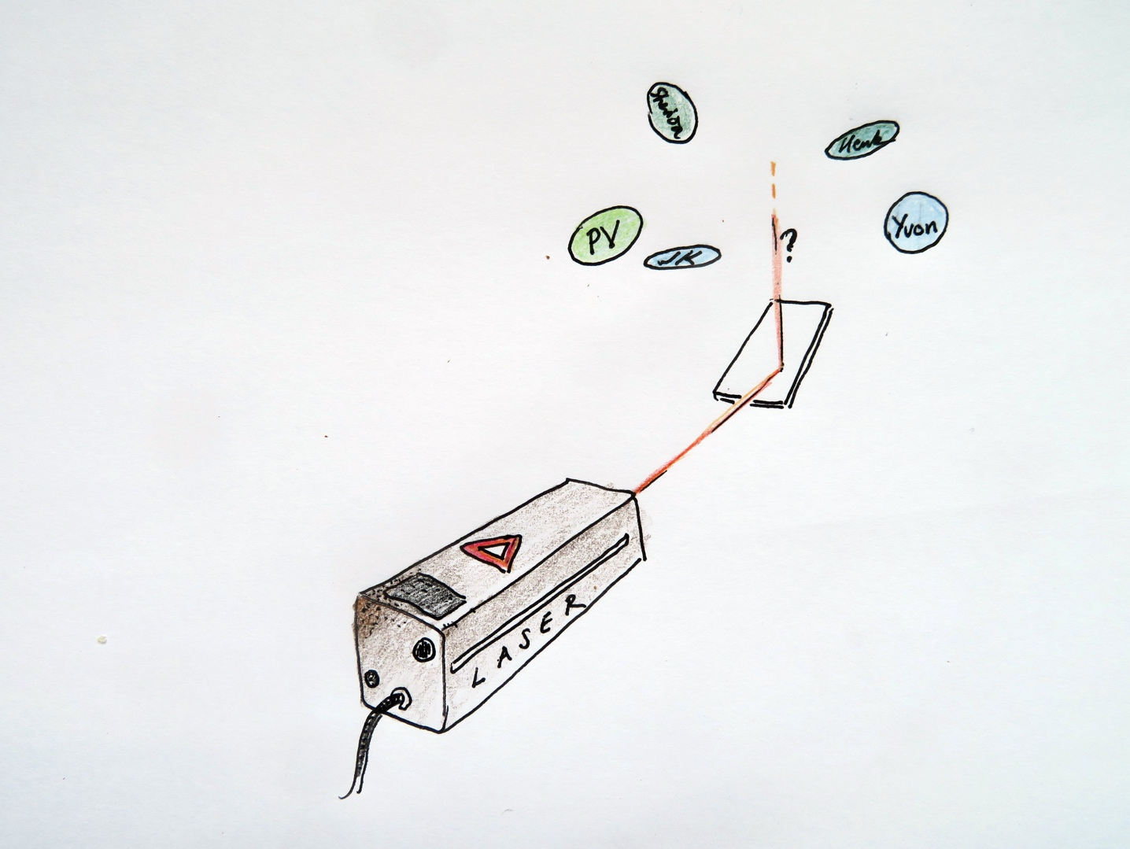**

Figure 1 Laser and mirror are relatively far apart*.*

## Equipment

Laser on a stand; flat mirror clamped on a stand, the mirror is covered by a piece of black cardboard which can be flipped over (adhesive tape on one side); classroom which can be darkened; round colored stickers (at least one for each student, the stickers could also be small post-its).

## Procedure

1. Each student writes his/her initials on the sticker(s).
2. Show the set-up. Point to the laser and the mirror covered with the cardboard. The laser causes a dot of light on the cover of the mirror. Then switch off the laser and flip over the cover of the mirror.
3. Tell the students that you will switch on the laser again after they paste their sticker somewhere on the wall where they expect the laser dot to appear after reflection. They have to remember where they put it and why there. There is a prize for the owner of the sticker closest to the actual dot.
4. Students walk around with their stickers. You ask them why they put their sticker at a certain place.
5. When all stickers are on the wall, ask the class to predict which one of the stickers will be the closest.
6. Switch on the laser. Discuss the results using Snell’s Law of Reflection and the reversibility of light rays. Use three rods: one for the incident ray, one for the normal, and one for the reflected ray. Show clearly that angles of incidence and reflection are equal AND that incident and reflected rays and the normal are in one plane.
7. You may repeat the whole procedure, but now with two mirrors.

## Physics background

The spot on the wall from which you can see the laser through the mirror is the spot where the laser ray will land after reflection. You use the principle of reversibility of light rays.

**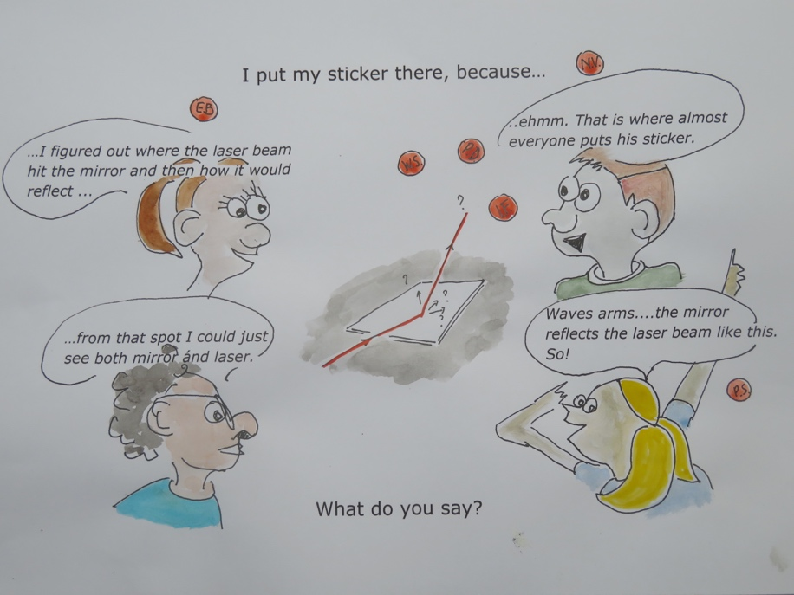**

Figure 2 Concept cartoon

# Making Einstein young again with an overhead projector

Maarten van Woerkom

**Time**: 15 minutes

**Age group**: 14 and up

**Concepts**: object distance, image distance, focal length, thin lens formula

## Introduction

With a clever use of the overhead projector we can make the old Einstein young again. See figures 1 and 2 and provide a nice conceptual exercise with the thin lens formula.

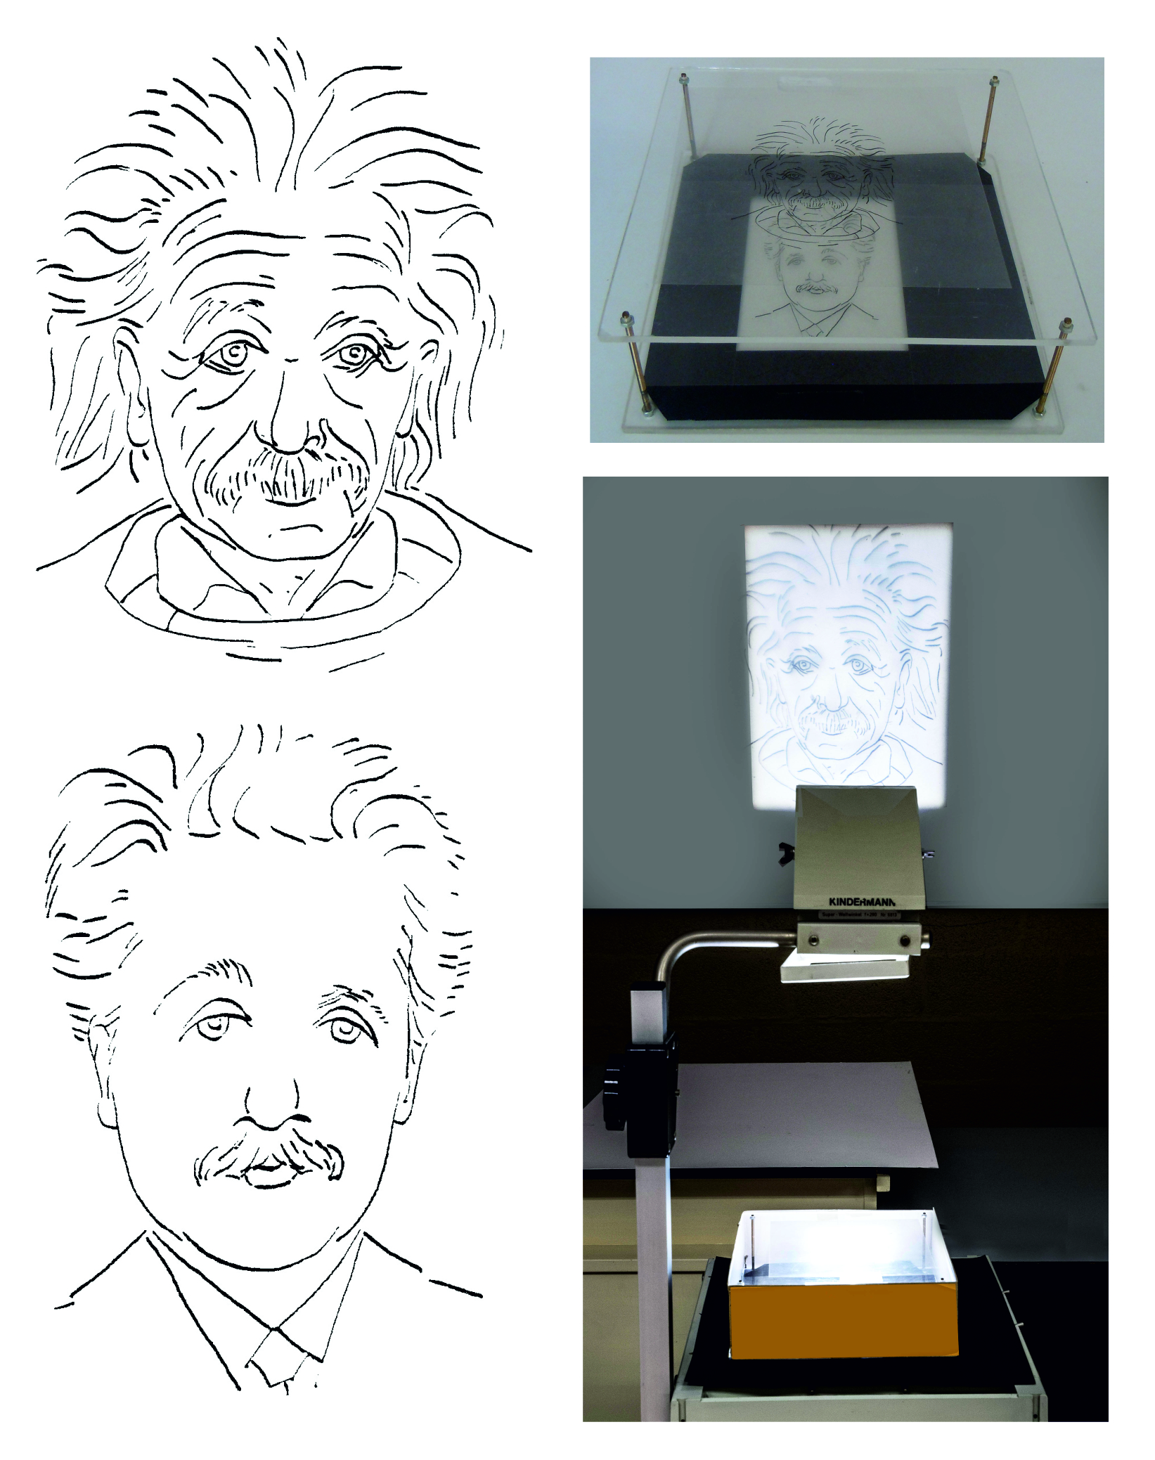

Figure 1. The old and the young Einstein to be scanned, enlarged and then printed on transparencies. The pictures can be dowloaded from ..... for printing. Note: site to be listed.

Figure 2. Box with a transparent Perspex or glass plate as top and bottom and opaque sides and with a black carton mask surrounding the bottom. The box is on top of the overhead projector.

## Equipment

An overheadprojector (OHP), a box (see instructions below), a white carton screen, a fixed screen or white wall, and transparencies of the old and young Einstein (figure 1).

Construct a box with a transparent top and bottom of Perspex or glass with a distance of about 6 cm between top and bottom. On the top put a transparency with the old Einstein and on the bottom the young Einstein. The sides of the box are opaque so the young Einstein is hidden from view. Surrounding the bottom of the box is a black mask (cut from black carton) which covers the remaining part of the overhead projector (figure 2).

## Preparation

Put the box on top of the overhead projector (figure 4). At the start adjust the overhead projector such that the old Einstein is on the screen.

|  |  |
| --- | --- |
|  |  |
| Figure 3 The old Einstein is on the screen; the young one appears by moving the white screen toward the OHP. Object distances are o1 and o2, and image distances are i1 and i2. | Figure 4 The old Einstein is on the screen, the young one appears when moving the OHP head (mirror + lens) downward. |

## Procedure

1. The old Einstein is projected on the screen. When you put the white carton on top of the fixed screen, one sees a sharp image of the old Einstein. However, when the white carton is moved in the direction of the OHP the old Einstein fades away and the young Einstein appears. When you have moved the carton 1 or 2 meters towards the OHP, then only the young Einstein appears. Pay attention to details such as the “growth” of the hair of the moustache and the hair on the head.
2. Again start with the old Einstein. Then move the head of the OHP (with mirror and lens) downward. The old Einstein fades away and the young Einstein appears. Moving the head of the OHP up again shows the reverse process, the old Einstein reappears at the expense of the young Einstein.

## Physics background

1. You start with object distance *o1* and image distance *i1.* When moving the white carton towards the projector, the image distance becomes smaller: *i2*.

But with a smaller image distance, the object distance becomes greater: *o2*. At that distance is the transparency with the young Einstein (figure 3) which now shows well defined on the screen. Because of the small “depth of field” of the lens, the old head is not visible anymore, unless the height of the box is too small.

1. Again start with object distance o*1* and image distance *i1*. When the head (mirror + lens) of the OHP is moved downward, then the image distance *i2* will not change. So *i = i1=i2*, the object distance will decrease.

So the object distance must remain the same as well. But at that distance is now the young Einstein instead of the old one. So if the head moves down by a distance which is the same as the height of the box, then the young Einstein will have a sharp image on the screen.

## Tips

* The glass/Perspex top and bottom should be surrounded by carton so the audience cannot look inside and cannot see the young Einstein picture. The audience only sees the box with on top the old Einstein.   
  The audience often suspects that there is some kind of computer inside the box. This computer is thought to change the image.
* A three-layer box is possible, but complicated and it is difficult to tune the distances properly.
* Instead of Einstein one could also use the head of a colleague in the school, but then you need an expert drawer of portraits.
* This demonstration can also be done as a laboratory experiment for students in different ways:
* By letting students work with the OHP.
* By letting students use typical laboratory materials. In that case one needs the portraits as slide to be placed in slide holders of a typical lab optics set.

The portraits of Einstein were drawn by colleague art teacher Ewald de Keijser. The idea to use portraits of Einstein this way came from grade 12 student Mieke Kerkhof, a golden tip!

# Infra-red investigations and surprises

**Time**: 10 minutes

**Age** group: 12 - 18

**Concepts**: infrared, visible light, absorption, transparency

## Introduction

Infrared radiation is a well-known subject in physics. Students get acquainted with it in junior secondary and learn about the properties of this kind of radiation in senior secondary. This demonstration is suitable for both junior and senior secondary physics. With the help of the IR- camera (FLIR) which can take photos and video, we can show the world in visible light and IR on an interactive white board or screen.

|  |  |  |
| --- | --- | --- |
|  |  |  |
| Figure 1 The person is standing behind a black plastic garbage bag which apparently is transparent for infrared but not for visible light. | Figure 2 The person is standing behind a glass plate or glass door which is not transparent for infrared. | Figure 3 The glass plate or door is transparent for visible light. |

Materials   
Black garbage bag, glass plate/door/window, IR camera (we used the FLIR C2).

## Preparation

Provide a garbage bag and a glass plate. Connect the IR-camera to the computer and set it to streaming mode so that you can use the live streaming feature of the software. Show the video on a digibord or screen.

## Procedure

1. Ask students to mention differences between IR and visible light.
2. What similarities do students know between IR and visible light?
3. Show examples with the IR camera of objects that are heat sources and explain that the camera creates false colors so that we can distinguish areas with different temperatures. The camera assigns different colors to different intensities.
4. Let a pupil stand behind a glass plate and film showing the pupil in the infrared modus (not in MSX mode). Students notice that infrared does not pass through the glass.
5. What will the IR camera show when a student is behind a glass window? Let students predict and then try this!
6. What does the glass do with IR? Does it absorb infrared, or does it mirror infrared? How can you test your answer with this equipment?
7. Use this experiment to discuss transparency, opacity or absorption of objects for electromagnetic radiation. For example, UV radiation and glass.

## Physics background

Visible light is not absorbed by the glass, but is absorbed by the black garbage bag. The opposite is true for IR radiation. Glass reflects infrared like a mirror.

## Tips

* When filming students behind a glass window, point the IR camera at a slight angle, or else you film your own IR reflection.
* Photograph yourself in front of a metal surface (for example aluminum foil), the photo will then indicate almost 37 degrees as surface temperature.  You just measured the temperature of your body and not the temperature of the metal surface!

## Further research

Investigate if IR radiation penetrates all kinds of plastic bags. Can you find material that is the most transparent to IR radiation?

Of course, there are countless possibilities for research with an infrared camera. For example, where is the greatest heat loss of a person? Is there a difference between bald people and people with a lot of hair? What is the influence of a beard? Are there diseases that you can diagnose with infrared 'thermometry'?

# LEDs and Photons

Leo te Brinke

**Time**: 10 minutes

**Age group**: 15 - 18

**Concepts**: particle-wave duality of light, quantization, threshold frequency, photons

It is not generally known that a light emitting diode (LED) can be used in reverse mode, as light sensor instead of lamp. A LED can generate a voltage when absorbing light, but under certain conditions ..... Just like a photocell a LED turns out to have a threshold wave length or frequency which also depends on the type of LED. This can only be explained with quantized light. I usually show this demonstration as a first lesson about photons, so before the photocell and the photo-electric effect.

## Equipment

Two LEDs with a clearly different color light but preferably in a colorless holder; a variable voltage source, with cables and appropriate resistors. A red laser pointer, a white light, a green laser pointer; a voltmeter with a very high internal resistance (10 MΩ or higher).

|  |  |
| --- | --- |
|  |  |
| Figure 1 Red light on a green LED: no voltage | Figure 2 White light on a green LED does generate a voltage |

## Preparation

For the first demonstration we make the LEDs shine by connecting each LED in forward direction in series with a resistor and a voltage source. Subsequent demonstrations are done *without* a voltage source, connecting the LEDs directly to a Voltmeter and illuminated them with a laser pointer or other source (figures 1 and 2). Set the voltmeter to a range of 0 – 2V.

## Procedure

In this description we use a red and a green LED but it could be other colors as long as one has a large wavelength and the other a much shorter wavelength. We connect both LEDs and make them shine. The LEDs convert electrical energy to light. *Would it be possible to do the opposite, to convert light into electrical energy? How can we investigate that?*

We connect the red LED with the voltmeter and illuminate it with a red laser (figure 1). *Would other colors of light such as white and green also generate a voltage over the LED?* Verify this with the white and green light sources (figure 2).

*Would intensity influence the voltage? How can we investigate this?* Vary the distance between LED and laser pointer, or use a filter that reduces the intensity of the laser pointer. So a LED can act like a solar cell. Please note that the voltage still depends on some other factors apart from the color such as other properties of the LED and resistance of the Voltmeter (should be large).

Then show with the white light source and the green laser pointer that the green LED can also generate a voltage when illuminated with white and green light even at low intensities. However, not when illuminated with red light. Please note that it does not make sense to ask for predictions when this is the first lesson about photons.

The question now is why even a modest intensity of white or green light does generate a voltage across the green LED and red light does not.

The explanation of physicists is that light energy is “quantized” in packages and that the energy of a package depends on the frequency of the light. Higher frequencies (thus smaller wavelengths) have more energy. So a green package has more energy than a red package. The green LED apparently needs a bigger energy package than a red LED in order to convert light into electrical energy and generate a voltage. And the voltage generated in a green LED is higher than that in a red LED. These energy packages of light are called light quanta or photons.

To further support this idea we can also look again at the conversion of electrical energy to light. To produce light the green LED needs a higher voltage than the red LED! Then we can get into determining Planck’s constant with LEDs, an experiment described elsewhere in this book.

## Physics background

The main principles have been mentioned above. After this demonstration it will be easier to understand the photo cell. It is better to avoid getting into explanations of how LEDs work. The LED in this demonstration is purely a black box whose behavior we cannot explain by light waves as a continuous flow of energy, but only with energy packages or light quanta which we have named photons.

A practical application of the same phenomenon is the fact that one cannot get a brown skin from visible light (behind a glass window), regardless of the intensity. UV energy packages are needed and they are absorbed by glass. Apparently pigment cells in our skin need energy packages with at least the energy of UV. The teacher can also refer to the fact that traditional photo paper is not sensitive for red light .... but who still knows that?

## Tips

* As the internal resistance of the Voltmeter is very high, the LED cannot produce a current and retains a fixed voltage. One needs an internal resistance of at least 10 MΩ in order to measure the voltage; with 1 MΩ the LED will already discharge.
* LEDs in a colored holder may not work in this experiment as there could be light absorption of certain colors in the holder.
* In our experiments small LEDs reacted better than big ones. It is unclear why.
* The extra resistance is only needed to limit the current when LEDs are on. The magnitude of the resistance depends on the power source and the maximum power of the LEDs. Most LEDs can stand a current of several tens of mA and this is sufficient for well visible light.
* It is possible to continue this demonstration with a determination of Planck’s constant with LEDs.

## Follow-up

One could also make a rough estimate of Planck’s constant. If the red LED generates 1.6V and you assume that each electron is excited with one photon, then one could determine the minimum energy of the photons and a minimum value of Planck’s constant. With 1.6 V and a wavelength of 633 nm (He-Ne-laser) we obtain 5.4 10-34 Js. (1.6 eV=h.c/λ).

*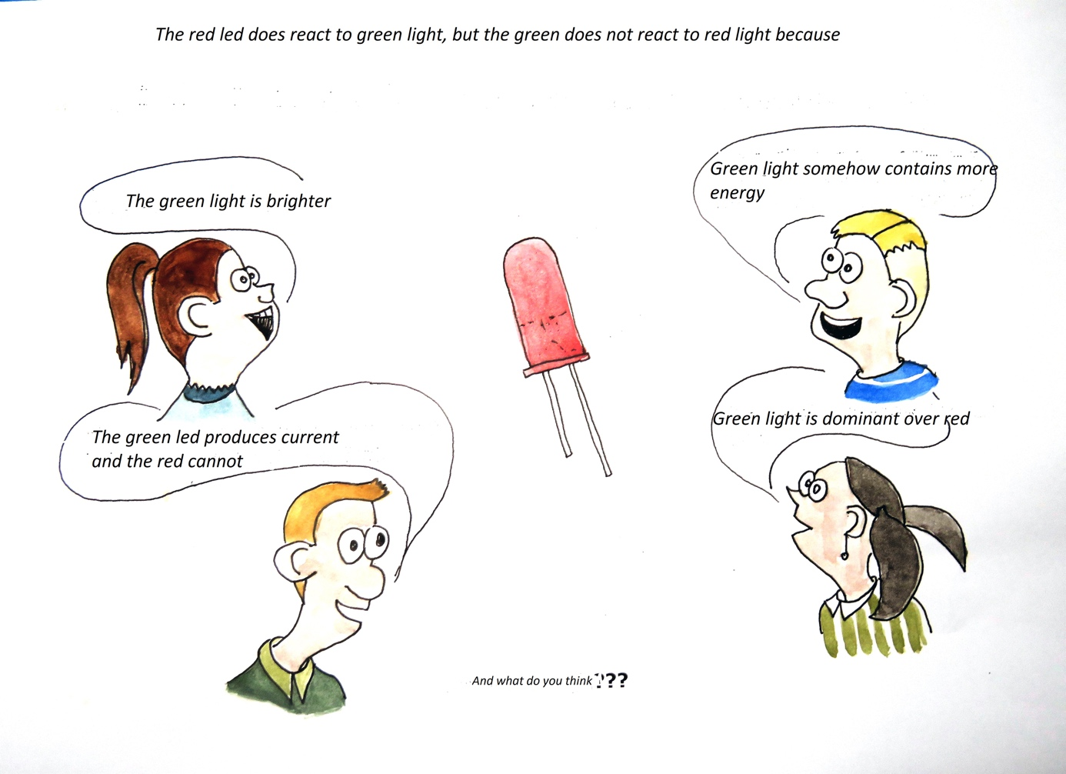*

# Writing with a Laser using Phosphorescence

Norbert van Veen

**Time:** 10 minutes

**Age group:** 16 - 18

**Concepts**: Phosphorescence, laser, photon energy, excitation, emission

## Introduction

Phosphorescence (luminescence) is a familiar phenomenon for many students. They recognize this from various "Glow in the Dark" stickers and objects. What they do not know is that a threshold energy is needed to make phosphorescence possible. We do this experiment using several lasers, each with different wavelengths. The intensity (or output power) of the laser makes no difference whether or not the surface will illuminate. We show this by using a He-Ne laser and by spreading the beam using a concave lens.

|  |  |
| --- | --- |
| IMG_2261.JPG | *IMG_2271.JPG* |
| Figure 1 The phosphorescent surface without excitation. | Figure 2 The phosphorescent surface after illumination with a laser (405 nm). Note: to be replaced by English text meaningful to students. |

## Materials

‘Glow in the Dark’ surface, 3 laser pointers with different wavelength (red, green and violet), dark room, He-Ne Laser, a darkened classroom.

## Preparation

Paint a wooden board (any size) a few times with "glow in the dark" paint. Make sure to keep the board in a dark bag until the room has been darkened. Place the board in front of the classroom and make sure you start with the red, then green and finally the violet laser.

## Procedure

1. *Today we will try a new kind of pen and school board.* With the violet laser draw some lines on the white wall. As soon as the laser is off, nothing visible remains. *Apparently, our pen does not work well on the wall*.
2. *Now write with a laser on the upper left-hand corner of the special board*. Just choose a word that is interesting for the class. Now the letters still light after the laser is off. That is interesting, writing with a laser!
3. *I have also a green and a red laser and a Helium-Neon laser with high intensity red light. Can we also write with those on this board? Why or why not?* Class discussion, or let students predict individually and discuss predictions and explanations with their seat mates.
4. *Let’s try.* Write on the board with the green and then with red laser. No letters after the lasers are off.
5. *And if we use a much higher intensity?* Does not work.
6. The teacher summarizes the results in a table on the board.
7. *How can we explain these results?* The expected answer is that “something” is excited by the laser light that then decays while emitting light. That “something” could be atoms of a special paint.
8. The teacher presents one-by-one the four energy schemes of figure 3 and asks: could this be the proper energy diagram? Which property fits and which one does not? The alternative is that students in duo’s or trio’s discuss diagrams A, B, C, and D and consider to what extent these diagrams can or cannot explain the phenomena.

*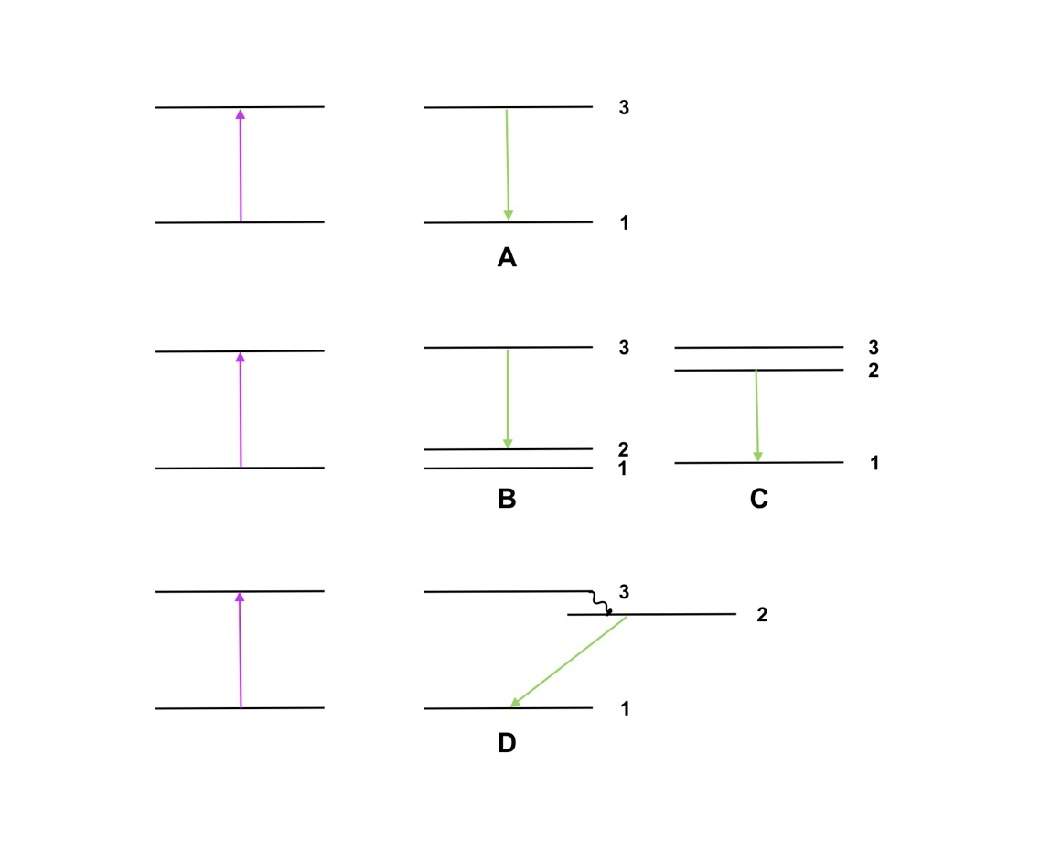*

Figure 3 Different energy schemes to explain the experiment, only one is correct.

## Possible explanations of emission with the energy scheme’s

In energy scheme A emission should have the same color as the laser light because the distance between energy levels is the same for excitation and emission (levels 1 and 3).

In energy scheme B the emission energy is indeed lower (from 3 to 2, green and not blue) but one would also expect emission of violet (directly from 3 to 1). Also, one might expect to cause also excitation with a green laser (directly from 2 to 3) which does not seem to happen.

Option C seems more likely (level 2 closer to level 3) but also here one would expect emission of both violet (from 3 to 1) and green light (from 2 to 1), and why is there no excitation from 1 to 2 directly with a green laser?

1. After this exercise with energy levels students will not yet come to a solution. Something new is needed. The teacher now tells that usually emission occurs within 10-8 seconds so there should not be any “after glow”. One can see that by shining the violet laser on various objects in the classroom. However, there are special materials such as “glow-in-the-dark” paint which exhibit “after glow”. In these materials there are energy levels which can exist much longer because the transition to a lower level or the ground state (for example level 2 to 1 in example D of figure 3) is forbidden by certain selection rules. Such levels cannot be reached by direct excitation (from 1 to 2) but only via a higher level (3). Then decay (from 2 to 1) will be very slow and so we will see “after glow”. This phenomenon is called phosphorescence.

## Physics background

Phosphorescence happens when a substance (in our case ZnS doped with Cu) is excited by a light source emitting photons with the right minimum energy, The substance then emits light, which slowly fades out. In the case of the ‘glow in the dark’ paint, the copper ensures that extra metastable energy states exist. These provide an energy difference in order of green light (+/- 500 nm) and for the gradual emission of this light. The afterglow can last for some time.

## Tips

Provide for a darkened room so that the effect is stronger.

There are many sources for “glow-in-the-dark” paint, see internet.

## Further research

The emission of the greenish light is temperature dependent (Randall & Wilkins, 1945), so increasing the temperature will shorten the afterglow. The surface can be cooled or heated to examine this effect.

## Literature

Randall, JT, Wilkins MHF (1945) Phosphorescence and Electron Traps. I The study of trap distributions. *Proceedings of the Royal Society* London 184, 365-389.

# Center of mass demo’s, feeling Physics with your own body!

Ed van den Berg

**Time**: 10 minutes

**Age range**: 6 and up (elementary and secondary)

**Concepts**: center of mass, distribution of mass, stability

## Introduction

Learning to recognize Physics in the everyday environment, visualizing Physics and “feeling” it with your own body, and then thinking back-and-forth between phenomena and concepts, that is the object of this series of demonstrations. That is possible with a class of 30 students, but also with a conference room of 500 students and parents. And it is fun!

|  |  |
| --- | --- |
|  |  |
| Figure 1 Philippine students try to pick up a banknote while standing with their heels and buttocks against the wall. | Figure 2 Us the center of mass concept to explain what might have happened. |
|  |  |
| Figure 3 A good marriage makes everything possible. | Figure 4 Is this possible? What can you conclude about the nature of the man? |

## Equipment

A ruler of 1 m or just a stick, various objects, the audience, and computer/beamer/powerpoint for some spectacular photo’s, and a loaded backpack.

## Preparation

At the location (classroom or auditorium), think briefly about maximizing visibility and how to create just enough movement space for the participating audience.

## Demo in steps

The description is for a demo during an event with a large audience. For a demo in the classroom the teacher will include more interaction.

1. Take a (meter)stick, put it on the table, pull it slowly over the edge until it starts to tip over. Then put your finger under this tip-over-point and lift the stick. The stick remains balanced. *It is as if all the mass of the stick is concentrated in that point. If we support that point, then the stick is balanced.* *That point we call the center of mass. As if that is where gravity acts on the stick.*
2. We can shift the location of the center of mass by adding masses on the left or the right. If we put our purse or some other object on one side, then the center of mass shifts toward that side. Show this!
3. *Our body also has a center of mass and that will probably be somewhere in our belly. Stand up everyone!* The teacher stands on top of a chair or table for visibility, his/her side toward the audience. *Lean forward, farther and farther. What do you feel? Cramp in your toes? When we lean over so much that our center of mass passes over our toes, then we have to take a step forward to avoid falling.*
4. Everyone*: lift up your right leg forward. What happens to your shoulders? They go backward. Now lift up your right leg sideways. What happens to your shoulders? They move in the opposite direction to compensate, so that the center of mass remains above the left leg standing on the floor.*
5. Everybody sits. The teacher remains sideways on top of the table and sinks through his/her legs. *My buttocks go backward, then something has to go forward to compensate. Knees and shoulders go forward.* Alternative is to take someone from the audience to illustrate these movements.
6. *There are times in life that the distribution of our mass changes.* The teacher takes a backpack or other large bag and puts that under his sweater or jacket and walks like a 9-month pregnant woman. *The shoulders have to go backward to compensate for the passenger up front, particularly when the pregnancy proceeds into the 9th month. Luckily after 9 months the passenger comes out and things go back to normal. However, men can have a similar problem with beer bellies and these do not go away after 9 months.*  All of this takes some acting, but it is fun.
7. Now hold the backpack in one hand with a stretched arm. *How does the body adjust to make sure that the center of mass of heavy backpack and body is still above the feet?*
8. Take some people from the audience and put them with their heels and buttocks against the wall. Put a bank note of $5 of $10 or equivalent currency in front of their feet (figure 1). *Keep your heels against the wall.* *If you can pick this up without falling, you can keep it.* But this is impossible, to pick up the banknote, the upper part of the body has to bend far, the center of mass will pass the toes.
9. A Powerpoint is available with some spectacular slides such as a bicycling bird (see also <https://www.youtube.com/watch?v=nrbvx17Ql-c> ), a flying donkey, a truck, and a tractor missing a wheel and ask for each slide how the center of mass concept can be used to explain the situation.
10. Show the photo of the child and the man on the see-saw. *Is this possible? Is something wrong? Using the center of mass concept or the law of moments of force, how can you explain?*

## Physics background

For definitions and background, see the physics textbooks.

## Extensions

There are many interesting phenomena around us which illustrate the power of the center of mass concept. Students could collect such examples like:

* A fishing heron has to stand such that the center of mass is above the toes. The long toes of some birds prevent them from tipping over.
* A chair can be made to lean over but when let go, returns to its normal position, as long as the center of mass has not passed the tipping point.
* A center of mass can be outside the actual object, example: a ring.
* Many sports rely on the manipulation of the center of mass: dance, gymnastics, figure skating.
* A high jumper jumps backward across the rope and bends his back in an arch such that the center of mass passes under the rope while the body passes over it (Fosbury flop).

1. Original idea by Biezeveld, Mathot and Brouwer in their Scope and Stevin textbook series [↑](#footnote-ref-1)